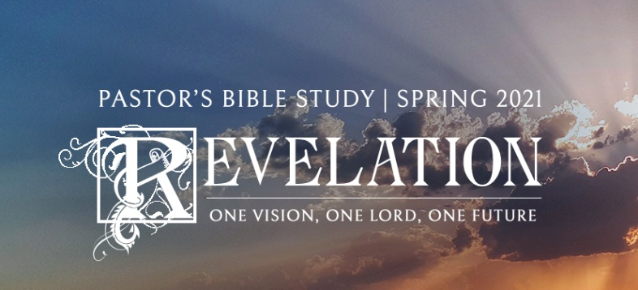

**Questions for Episodes 18-19**

February 24/25, March 3/4 2021

February 24/25

1. What is the most extreme or humiliating fall from power you have ever seen someone undergo?
2. What place epitomizes evil to you?
3. What amazing sight did John see? (18:1)
4. How did John describe the angel he saw coming down from heaven? (18:1)
5. What pronouncement did the angel bring? (18:2)
6. Why did the angel say that Babylon was being judged? (18:3)
7. What did a voice from heaven urge? (18:4)
8. What specific message of judgment did the angel bring concerning Babylon's sins? (18:5, 8)
9. How will the fall of Babylon affect rulers and merchants all over the earth? (18:9, 11, 15)
10. What will happen to Babylon's wealth? (18:10-19)
11. What instructions did the angel give for heaven and its inhabitants? (18:20)
12. Near the end of the vision of Babylon's fall, what did a mighty angel do? (18:21)
13. What did the mighty angel's action illustrate? (18:21)
14. How will Babylon be judged? (18:22-23)
15. What symbol of violence was found in Babylon? (18:24)
16. What do you think Babylon symbolizes or represents?
17. What warning does the harlot's fate offer us today?
18. Why do you think the kings, merchants, and sailors are singled out to mourn the great city's fall?
19. In what ways can we become ensnared by wealth?
20. What can we do to avoid being slaves to money?
21. What worldly attitudes and actions hinder us from having an impact on the world around us?

March 3/4

1. What is one of the most memorable weddings or banquets you have ever been to?
2. What was the roar that John heard coming from heaven? (19:1)
3. Why were the inhabitants of heaven praising God? (19:1-2)
4. Who shouted? Why? (19:3)
5. How did the creatures closest to God act? (19:4)
6. Why did the great multitude urge everyone to be happy? How? (19:6-7)
7. In what ways did the bride get ready for the heavenly wedding? (19:7-8)
8. Who is called "blessed"? (19:9)
9. What was the angel's instruction to John? (19:10)
10. What did John learn about worship? (19:10)
11. What did John learn about angels? (19:10)
12. How would you describe the mood in heaven when judgment is done and God prepares to unite believers with Him forever?
13. Why do you think "hallelujah" is repeated again and again in heaven?
14. What are some implications of the fact that Christ's relationship with the church is described as a marriage?
15. In what ways ought we to act as people "engaged" to Christ?
16. Who does God invite to the wedding supper of the Lamb? How?
17. What is one way you could become a more worshipful person in how you participate in worship?