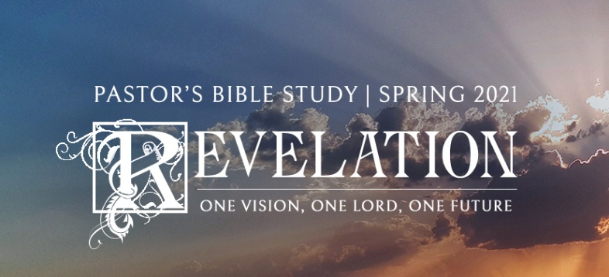

**Questions for Episode 17**

February 18, 2021

1. When and where have you most sensed the awesomeness and greatness of God?
2. What great sign did John see in heaven? (15:1)
3. Why did John refer to the plagues he saw as the "seven last plagues"? (15:1)
4. Who will be "victorious over the beast"? (15:2)
5. By what names was God called in the heavenly hymn heard by John? (15:3-4)
6. What was given to the seven angels? (15:7)
7. What events took place in the heavenly temple after the angels were dispatched with their plagues? (15:8)
8. Based on this passage, what new insights do you have about heaven?
9. What God-given provisions can you use today in your battle to be victorious over the devil?
10. What did John hear from the heavenly temple? (16:1)
11. What happened when the first angel poured out his bowl? (16:2)
12. What happened when the second angel emptied his bowl? (16:3)
13. What happened in the wake of the third angel pouring out his bowl? (16:4)
14. What kinds of judgment did the fourth bowl contain? (16:8-9)
15. What effect did the judgment of the fourth bowl have? (16:9)
16. What effect did the "raising of the thermostat" have on the earth's inhabitants? (16:9)
17. What happened when the fifth angel poured out his bowl? (16:10-11)
18. Where was the judgment of the sixth angel directed? Why? (16:12)
19. What was the appearance of the three evil spirits after the judgment of bowl number six? (16:13-14)
20. What were the results when the seventh angel poured out his bowl of judgment? (16:17-21)
21. What kinds of natural disasters would you least like to be in the middle of?
22. What injustices in the world sometimes cause you to wonder if God is just?
23. How (if at all) do you think current events fit in with the judgments described in this passage?
24. How is the first plague appropriate for those who have allowed the mark of the beast on their bodies?
25. Why would people undergoing judgment still not turn to God in repentance and for salvation?
26. How did the angel describe the evil of the "great prostitute"? (17:2)
27. Why will people all over the world be astonished at the beast? (17:8)
28. What is the relationship between the beast, the ten kings, and the prostitute? (17:16-18)
29. Why do you think idolatry (worship of false gods) is described as adultery in the Bible?
30. In what way is the beast's "resurrection" a weak imitation of Christ's resurrection?
31. What in your opinion is the best way to understand the symbolism in this passage ---- the prostitute, the seven heads or hills, and the ten kings?
32. What systems ("babylons") in the world today are hostile to God?