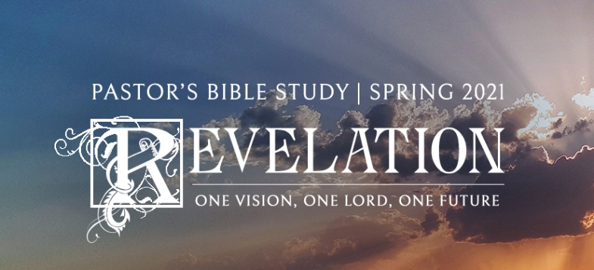

The Three Angels and the Reaping of the Harvest

Episode 16

Revelation 14:6-20

February 10/11, 2021

**The Proclamation of the Three Angels**

1. **The First Angel (14:6-7)**: **The Truth of the Gospel set loose**—the Proclamation of the Gospel to all the world. (Mission Movement).
   1. The Great Commission (Matthew 28:18-20).
   2. A Historicist Interpretation – The Reformation and the World Mission Movement.
   3. **14:6-7** -- Traditionally, many non-Roman Catholic commentators identified the first angel with Martin Luther because his message was the Eternal Gospel. Verse 6 especially points more to a world-wide spread of this Gospel, via missions -- **"…to every nation, tribe, language and people."**

d. One commentator (Adam Clarke) has associated the first angel with the British Bible Society -- the first of the great World-Wide Mission agencies. The point is, once the Gospel had been restored by the Reformation people of faith realized anew the urgency of the Great Commission. The Reformation had made popular the idea that the Bible should be available to people in their own language and the invention of the printing press, just prior to the Reformation, made possible the rapid spread of Bibles that people could read for themselves.

e. While we take this for granted, if you would have told someone a hundred years before Luther about these two developments they would not have believed it possible.

**II. The Second Angel (8):** **False worship and the False Gospel of the Counterfeit Trinity defied.**

1. **The Fall of Babylon**: Fallen is “Babylon the Great.”
   1. **Babylon=Pagan Culture: Culture in Rebellion against God. The culture that defies God is itself unmasked and condemned.**
   2. ***= “****the wine of the passion of her sexual immorality.” [1]*
2. The Gospel shall be heard amongst the false teaching until the end of time.
3. Historicists portray this as the downfall and the break-up of medieval Papal totalitarianism. With the image of Christ's return and the reaping we are given the impression that never again shall the Gospel be as hidden as it was under the Papacy of pre-Reformation times.
4. **The Third Angel (9-13): Warning of the Harvest** 
   1. Now that the Gospel is again being proclaimed plainly and clearly, and Bibles are available, people again have a choice between truth and error. Such choice is a form of judgment in that, with the truth available, they can reject it. Rejection of the truth brings both eternal judgment and judgment here on earth, as Romans 1:18-32 illustrates.
   2. **14:11-13** Here it is clear that the condemned are not annihilated. Their suffering is forever. Verse 12 is the usual refrain in Revelation after the suffering of the saints is warned about -- a call for patient endurance, and single-minded faithfulness to Christ, which are the keys to faithfulness unto death. Verse 13 reinforces this by adding the encouragement that believers who endure in the faith will be given more in heaven than they ever lost in this life.
5. **the Harvest of the Earth and the Great Winepress (14:14–20)**
6. A description of the second coming of Christ as the harvest over which He presides (Matt. 13:36–43; cf. Joel 3:12–16) as the “one like a son of man” (1:13; cf. Dan. 7:13, 14).
   1. John concludes this interlude with two visions: one of the harvest of grain (vv. 14–16) and the second of the vintage of God’s wrath (vv. 17–20).
   2. The grain harvest may symbolize the harvest of the righteous (Luke 3:17), followed by the harvest of the wicked (grapes).
   3. **The first** pictures the eschatological judgment with special reference to the gathering of the righteous into salvation; **the second** pictures the judgment of the wicked into condemnation.
   4. The presupposition of these two visions is that the final spiritual struggle has occurred between Christ and Antichrist and men have made their decision: loyalty to Christ even unto martyrdom, or worship of the beast.
   5. These two visions portray the fate of these two groups. **The actual fulfillment of these visions does not occur until chapters 19–20.**
7. **The Reaping of the Harvest of the Lord** (**14:14-16)**
   1. Verse 14. The natural way to understand the **one like a son of man** whom John sees is that he is the returning Messiah, Christ himself; and it is difficult to avoid this conclusion. The idea of “one like a son of man” goes back to the vision of the coming of the Kingdom of God in Dan. 7:13 where one like a son of man was presented to the Ancient of Days and received an everlasting kingdom that all peoples and nations should serve him. Jesus himself spoke of the role of the Son of man in the eschatological judgment, which he likened to a harvest (Matt. 13:37ff.); and again, he portrayed the eschatological mission of the Son of man in the separation of the righteous from the wicked (Matt. 25:31ff.). John has earlier likened the exalted Jesus to one like a son of man (1:13).
   2. The Son of man is seen **seated on a white cloud.** In the Revelation, white has a symbolic significance and is always associated with the things of God (see note on 6:2). The white cloud is reminiscent of the bright cloud seen on the Mount of Transfiguration (Matt. 17:5). The return of Christ is often pictured as attended with clouds (Matt. 24:30; Rev. 1:7). The **golden crown** is symbolic of triumph, and the **sharp sickle** is the instrument of harvesting the grain.[2]
8. **The *Grim* Reaper (14:17-20)**
   1. Portrays the judgment of unbelievers who rejected the Word of the Gospel now being clearly proclaimed in the shadow of the Reformation (**"clusters from the vine of the earth"** as opposed to those branches grafted onto Christ). They are thrown into the **"great winepress of God's wrath"** which clearly indicates judgment. In the end, the only sin that damns is unbelief. In addition, the unbelievers will be suffering at their own hands
   2. The last part of **14:20** is very difficult -- but clearly portrays what we term "*a blood bath*" as a result of judgment. To take this literally would mean having to discuss a lake of human blood 184 miles across and four to five feet deep. Rather, one commentator points to the figure as given in the Greek text: 1600. If four is taken here, as other places, as the number of the world then 4 x 4 x (10 x 10) = the world.
      1. **4 x 4 x (10 x 10)**: **The world times the world again times completeness times completeness intensified equals the Universal Judgment of the Wicked.**
   3. The text is once again reminding those who face persecution for faithfulness to Christ that their persecutors shall face judgment for their actions. This is fitting as just a few verses earlier the text had reminded the faithful of their reward for faithfulness.

1. [*The Holy Bible: English Standard Version*](https://ref.ly/logosres/esv?ref=BibleESV.Re14.8&off=120&ctx=e+all+nations+drink+~t%EF%BB%BF%E2%80%A2the+wine+of+the+p). (2016). (Re 14:8). Wheaton, IL: Crossway Bibles.
2. Ladd, G. E. (1972). [*A Commentary on the Revelation of John*](https://ref.ly/logosres/cmmntryrvltnjhn?ref=Bible.Re14.14-16&off=41&ctx=he+Grain+(14:14%E2%80%9316)%0a~John+concludes+this+) (pp. 198–200). Grand Rapids, MI: William B. Eerdmans Publishing Company.