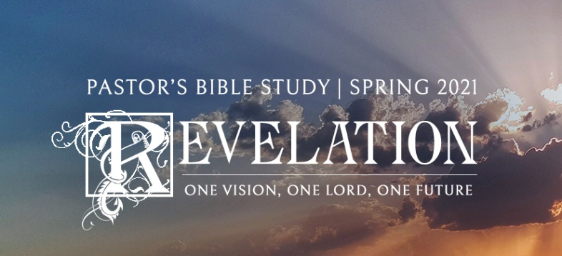

**Questions for Episode 16**

February 10/11, 2021

1. If you could get on international television and deliver a 10-second message to the whole human race, what would you say?
2. What was an angel dispatched to do? (14:6)
3. Why was it important that people heed the angel's message? (14:7)
4. What pronouncement did the second angel make? (14:8)
5. How was Babylon's sin described by the second angel? (14:9)
6. What warning did the third angel give? (14:9-10)
7. How is God's judgment on those who worship the beast pictured? (14:10)
8. What words are used to portray God's anger over sin? (14:10)
9. What does the future hold for those who do not believe? (14:10-11)
10. How should Christians respond to this sober warning? (14:12)
11. What instructions did John receive from heaven? (14:13)
12. In what sense are the dead blessed? (14:13)
13. What temptations and trials make it difficult to live for Christ in this society?
14. How is it significant that the angel proclaimed the eternal gospel to "every nation, tribe, language and people"?
15. What does it mean to fear God?
16. Why do we need "patient endurance" as followers of Christ?
17. What do you think is the average person's view of heaven?
18. What unusual instrument did the one "like a son of man" have in his possession? (14:14)
19. What happened as John stared at the angel sitting on a cloud? (14:15)
20. What did the angel from the heavenly temple tell the other angel to do? Why? (14:15)
21. Why did the one angel command the other to harvest the earth? (14:15)
22. How did the one seated on the cloud respond to the angel's command? (14:16)
23. How did John describe the next angel he saw? (14:17)
24. What instructions did the angel give to the one with the "sharp sickle"? (14:18) *(The Grim Reaper?)*
25. What happened to the grapes that were gathered by the reaping angel? (14:19-20)
26. How much blood was produced by the crushing of the "grapes"? (14:20)
27. How would you answer a non-Christian's charge that the Bible is too full of blood and judgment?
28. Why do you think God delays His judgment when the world is already filled with evil?
29. How do we know that God takes our sin seriously?
30. How (if at all) would it change your view of God if God didn't punish sin?
31. In what way(s) can you express your gratitude to God for sparing you from His wrath?