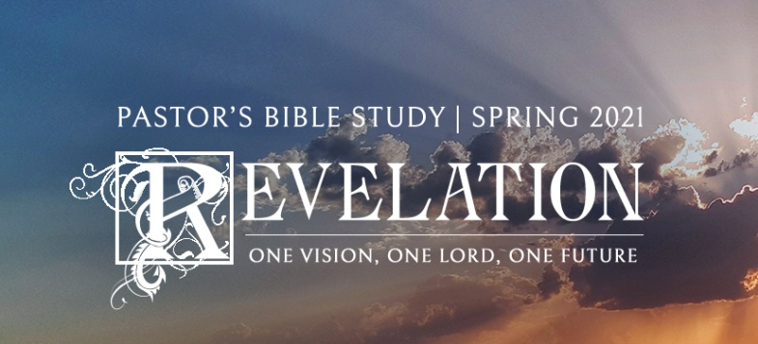

The 144,000

Episode 15

Revelation 14:1-5

February 3/4, 2021

**Introduction: Synopsis of the Fourth Theme** **of Revelation**

**The Fourth Theme** **of Revelation** is that the Victorious Christ will come to judge the living and the dead throughout history. During the Tribulation, all people were marked one of two ways. Either they bore the mark of Christ on their foreheads, indicating that they trusted in Jesus for salvation, or they bore the mark of the beast, indicating that they had put their faith in the counterfeit salvation of the Antichrist. There will be no middle ground. Those who bore the mark of the Lamb were persecuted, murdered and impoverished by the antichrist, and now it is time for those who had it easy because they served the beast to receive comeuppance.

At the judgment, the Lord will rule on each life. If one’s name is written in the books of works, then he will be judged according to God’s justice. He will get what he deserves for all the deeds, good and evil, great and small, that he has ever done. But if his name is written in the Lamb’s book of life, he will be judged according to God’s mercy. And all those who rely on their own righteousness will be cast into a lake of fire for all eternity because they will be found wanting --- they ignored the warnings, they rejected His love. *For Our Lord is a consuming fire (Hebrews 12:29.*

In these last days, God’s judgment will be executed on all people. Those who have served evil, or their own self-interests, those who have not been washed clean by the blood of Christ will perish in their sin, and the full weight of their evil will consume them. But those who have followed Christ, and who trust in him alone for their salvation, shall be ushered into the joy of his eternal kingdom in the New Heaven and New Earth.

**I. The 144, 000**

a. **14:1** -- We begin with a very clear description of Christ (the Lamb) surrounded by the saved (**"those having His Father's Name written on their foreheads"**). This description of the saved validates our understanding of Revelation 7:3 and 22:4.

b. Revelation 22:4 makes even more clear that this phrase is referring to all the saved since all who have believed, including those raised from the dead on the last day (all identified in Rev. 20:11 through 22:3), are so described. This identification then gives us the key to understanding the 144,000 mentioned in verse 3.

c. What does 144,000 represent? Early on, the church understood that this is the total number of all believers. This is not to say that only 144,000 will be saved.

d. How do we arrive at 144,000 for the total number (much larger) of all the saved?

12 = Old Testament Church

x 12 = New Testament Church

144

x 1000 *A great inclusive number to the people of John's times,*   
144,000 -- such as we would say "**a zillion**" without being able to comprehend such a figure.

e. The significance is that it is a total number of all the saved in the history of the world. What they all have in common is their faith in Jesus Christ as their Lord and Savior.

f. **14:3** -- They sing a **"new song."** This song is the Gospel, the witness in personal faith as Jesus Christ is one's own sin offering before God.

i. **14:2** -- Harps are mentioned three times in Revelation, never in the context of someone sitting on a cloud, strumming it. Harps are always mentioned in the context of the praise of God around His throne. Such passages show how wrong those are who teach that it is not God-pleasing to have music accompany our singing and praise of God.

ii. You will remember that during the persecution of the saints they had praised Christ and God, but also asked, **"How long . . . until You judge the inhabitants of the earth and avenge our blood."** (6:10) Their new song now is one of not only joy and gratitude for salvation, but also for deliverance of the church on earth from bondage in a way that still more could be saved (i.e., the Reformation).

g. **14:4-5** -- **". . . did not defile themselves with women . . ."** -- Notice the plural, "*women*." In the Roman culture, like the culture today (just watch a few TV programs), it is considered abnormal for a man (or a woman for that matter) to restrict their sexual activity to only their spouse for their entire lives. As the rest of the verse makes clear, their marital fidelity was a reflection of living out the new lives that Christ has won for them. Verse 5 continues this theme. **Pagan Culture: Culture in Rebellion against God.**

h. **"They are Blameless"** further identifies this group as the ***"Holy Christian Church"*** -- **the Universal invisible Church** -- the whole number of those who are Holy because of Christ.