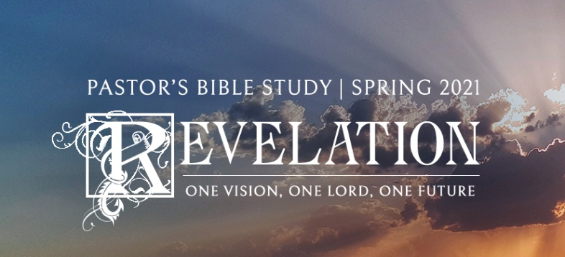

2020 was a year like no other. What will 2021 be like and what does the Bible tell us about the future?

This Winter and Spring, the Pastor’s Bible Study (PBS), led by Dr. Bob Fuller, will continue our study of the book of Revelation. Many people see the last book of the Bible as a futuristic preview of ominous warning. Revelation, however, is a book of hope for Christians of all centuries (not just the end times).

Join Dr. Bob Fuller on Thursday mornings beginning January 7 at 9:30 a.m. in the Sanctuary (so we can spread out), or virtually via live stream through the FPC app or fpcsanantonio.org.

We will also offer a special Wednesday Evening Edition of PBS, beginning on January 6, 2021. The group will meet on Wednesday evenings in Covenant Hall at 7:00 p.m.

Jan 6/7 | Trumpets and Woes I | 8:2-12
Jan 13/14 | Trumpets and Woes II | 8:13-11:19
Jan 20/21 | Flashback | 12:1-17
Jan 27/28 | The Rise of the Beast | 13:1-18
Feb 3/4 | The 144,000 and the Reaping of Wrath 14:1-5
Feb 10/11 | The Three Angels | 14:6-20
Feb 18 (No Wed. evening- | The Bowls and the Harlot of Babylon 15:1-17:18
Ash Wednesday)
Feb 24/25 | The Fall of the Harlot and the Rising Bride 18:1-24
March 3/4 | The Marriage Feast and the Rapture 19:1-10
March 10/11 | Spring Break
March 17/18 | The Second Coming of Christ | 19:11-20:15
March 24/25 | The New Heaven and the New Earth 20:1-22:21

