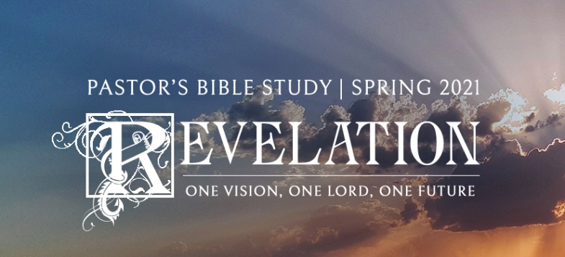

Trumpets and Woes,

Part 2

Revelation 8:13-11:19

January 13/14, 2021

**I. The Bird of Woe**

a. (8:13) As I watched, I heard an eagle (vulture?) that was flying in midair call out in a loud voice: “Woe! Woe! Woe to the inhabitants of the earth, because of the trumpet blasts about to be sounded by the other three angels!”

b. The Oracle of Weal vs. The Oracle of Woe: Beatitudes “Blessed is…; not ‘bless your heart.”

c. Woe raised to the Third Degree: Woe, Woe, Woe- Opposite of Holy, Holy, Holy.

d. *Woe is me*- “Oy Ve”: A Curse.

**II. The Fifth Trumpet- The Bottomless Pit, The Locusts and Apollyon (The First Woe- Internal Decay)**

a. Star-

i. Fallen Angel, Demon (to “him”- not “it”); not an object but a being.

ii. Isaiah 14:12:"How you have fallen from Heaven... "O Day Star, son of Dawn" (NRSV) or as the KJV rendered it less generically “O Lucifer, Son of the Morning.

iii. Is this History, Future—or even Pre-history?

b. Locusts-

i. Not locusts that destroy vegetation but that attack the wicked (Joel 2:1-11).

ii. Not given authority to kill, only to torment: “They will seek death and not find it…”

iii. The description (9:7-10)—Sound like the “Idols” the swarm over a culture. They can but would not kill.

iv. Seem to represent internal decay without repentance, as opposed to the Horsemen of the next trumpet which represent foreign Invasion.

v. Society going into “the pits.”

c. The Seal of God; The Mark of the Lamb - Like the Blood over the Door at Passover (9:4).

d. Apollyon / Abaddon-

i. In the Greek language, the name *Apollyon* means "the destroyer" and in the Bible it is one of the names given to one who is also known as Beelzebub, Lucifer, Satan, the Devil.

ii. Satan’s power is limited. Under this tribulation, he afflicts only his own worshippers/ pawns. The Earth is exempted and those with the seal of Christ are exempted.

iii. Satan is fallen, he is judged, his power over a person's life may be broken and his temptations and ruses may be resisted. He is a defeated enemy. The Old and New Testaments include a number of reports of demonic assault, from the garden of Eden to Jesus and his disciples casting out demons during his public ministry and the temptation of Christ himself.

vii. Scripture defines Satan's limitations in relation to a believer (Luke 22:31). Satan's power is checked by the believer's relationship with God.

**III. The Sixth Trumpet- The Threat from the Middle East (The Second Woe- Foreign [Gentile] Invasion)**

a. The Angels that had held the forces of the “east” at bay now release them.

i. (Historical) Roman Fear of the Parthians (Persians).

ii. Mohammed, Saracens and Saladin? Ottomans?

iii. Contemporary—War arising from the Middle East (Arabs and Iranians).

iv. Literal?—These are literally Divine Warriors – not symbolic of any human group.

b. War: Foreign Invasion

i. 200 million Horsemen; Huge numbers!

ii. Fire, Smoke, and Brimstone that kills a third of Humanity (Cannons / Gunpowder used successfully by the Ottomans to take Constantinople; Nuclear weapons?)

c. Repentance

i. Should we have repented after 9/11? Should we repent now?

ii. Verse 20 - Humanity still refuses to repent: This verse is a clear indication of the purpose of the plagues and the woes and the tribulations; to cause people to repent (turn around).

iii. For the non-believer: tribulation causes failure—failure produces cowardice—cowardice produces despair.

iv. For the believer: tribulation causes perseverance—perseverance produces character, and character produces hope (Romans 5:4).

**IV. The Interlude (Rich with Old Testament Imagery)**

a. The Angel with the Little Scroll

i. The Secret Revelation of the 7 thunders 10:4 *And when the seven thunders had sounded, I was about to write, but I heard a voice from heaven saying, "Seal up what the seven thunders have said, and do not write it down."*

ii. John told to take and devour the scroll.

iii. Whatever is in the scroll, John is supposed to know and internalize (eat), but not to tell. There are certain things (many things) that God is not going to reveal about His will.

b. Announcement about the seventh trumpet: 10:7*"There will be no more delay, but in the days when the seventh angel is to blow his trumpet, the mystery of God will be fulfilled, as he announced to his servants the prophets."*

c. The “Target” or context of the last three trumpets seems to be Jerusalem. Preterists see all of these events as relating directly to the destruction of the temple in 70 AD.

d. *The Measuring of the Temple (How big; how many?)

i. The Literal Temple?

ii. The Body of Christ?

iii. Not Counting the Gentiles (The `gentiles' rage against it).

iv. Given to the Gentiles for 1260 Days= 3 1/2 years: Half of the Seven Years.

e. *The Two witnesses (Martyrs): they are like Old Testament Prophets.

i. *Elijah- 11:6 They have authority to shut the sky, so that no rain may fall during the days of their prophesying.

ii. "Moses- and they have authority over the waters to turn them into blood, and to strike the earth with every kind of plague, as often as they desire.

iii. These are the two figures present at the Transfiguration of Christ.

f. *The Two witnesses are conquered and killed by the beast from the bottomless pit (Matthew 23:37 *O Jerusalem, Jerusalem, you who kill the prophets and stone those sent to you, how often I have longed to gather your children together, as a hen gathers her chicks under her wings, but you were not willing*.)

i. *The Sodom of Egypt-Sodom =immorality, Egypt = Bondage; Jerusalem (where Jesus was slain); Jerusalem exposed for its apostasy.

ii. The two great Prophetic Charges: Idolatry and Injustice.

iii. After 3 1/2 days, they are raised and vindicated by God (allusion to Daniel) by destruction.

**V. The Seventh Trumpet (A return to the Heavenly Worship)**

a. "God's Temple in heaven was opened" revealing the Ark ofthe Covenant, the sign of God's presence with his people.

b. *The**issue of all judgments, the essence of all the rewards, is to**have a more perfect access to God and a clearer vision of his**splendor.-*M

c. The Beatific vision - the ultimate prophecy of weal afterthe "woes."

**But The Third Woe is coming Quickly…**