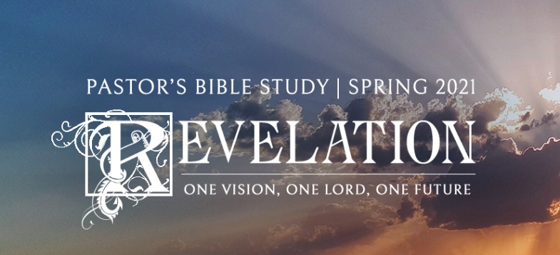

Trumpets and Woes,

Part 1

Revelation 8:2-12

January 6/7, 2021

**I. Introduction to the Seven Trumpets**

a. The prayers are heard in heaven, and they have an effect. - *Rev. 8:3-4*

b. The effect is not merely a subjective release in the worshipper; the prayers of the saints cause things to happen on earth. The saint’s prayers do not result in deliverance from historical troubles but the deliverance from the world and history by the end- time (eschatological) appearance of God's Kingdom. This is the cumulative effect of the prayers of the saints ­"Thy Kingdom Come.”

**II. Comparison of the Seven Seals and Seven Trumpets**

a. The Seven Trumpets are not necessarily "sequential" to the seven seals. Rather, the effect is cumulative. (Don't get hung up on the sequence between the two sets.)

b. There is an intensification of the sufferings increases (A ***third*** of the earth is dealt a blow rather than a ***quarter***.) (See the Parallel Sheet)

c. Are these events past, present, future, ongoing or symbolic?

**III. The First Four Trumpets**

a. A set of tribulations—just like the first four seals. Whereas the first four seals were God’s judgment on human civilization run amuck, these four tribulations strike the cosmos (or creation) itself. Natural calamities (signs in the heavens and the earth).

b. The four “zones” of the creation - Vegetation, Sea, Freshwater, Sky.

c. “Four” (E.W. Bullinger)

i. Three is the number of Divine Perfection (as in the Trinity).

ii. Four, being 3+1, is the number of perfection within creation.

iii. The Four Regions of the Earth: North, South, East, and West.

iv. The number of the great “elements”- earth, air, fire and water.

v. The classic divisions of the day - morning, noon, evening, midnight.

vi. Variations of Lunar phases.

vii. The first square number—also denotes clean divisions.

**IV. The First Trumpet: Vegetation (8:7)**

a. Hail is a symbol of God’s judgment (Job 38:22-23 and the combination of hail and fire (or thunderbolts) recalls the plagues in Egypt (Exodus).

b. Historicist/ Preterist Schools suggest understanding these hailstorms as wars—either related to the barbarian invasions and subsequent destruction of the Roman empire, or the destruction of Israel/ Jerusalem by the Romans from 66-70 AD.

c. Hal Lindsey (Dispensationalist) has suggested that this is a symbolic description of nuclear fallout and its effects. Others have suggested “Acid Rain” greenhouse effects, ecological disaster. etc.

d. Some suggest that the “trees and grass” represent people, others say that it means literally trees, grass and other vegetation.

e. Spiritualists: Like the first four seals, these do not represent datable events, but calamities that occur again and again in history, but that will intensify before the coming of Christ (personally or cosmically).

**V. The Second Trumpet: Sea- The Mountain Thrown into the Sea (8:8-9)**

a. Symbolic

i. Mountain - A natural symbol of power: Mount Olympus, Mount Zion, Mount Sinai,

Mt. Everest. Mt. Rushmore, Mt. Fuji; the pyramids.

ii. Combined with “Sea”= a destructive “sea power”—think the Philistines/ Phoenecians, Vandals, or Vikings, or Pirates—Terror and death coming from the “Sea.”

b. Historical

i. Roman destruction of Jerusalem: God’s Holy “Mountain” Zion, burning and thrown down into “chaos”- Sea.

c. Natural

i. The Mediterranean is a “ring of fire”- Volcanic Activity. Volcano.

ii. Volcanic Eruption/ Earthquake.

*iii. Seismos*- Poseidon (in Matthew [8:24] - Jesus does not necessarily still a windstorm but an earthquake- a *seismos*).

iv. Tsunami- A tidal wave caused by an earthquake.

**VI. The Third Trumpet: Fresh water (8:10-11)**

a. *Wormwood*: The popular name for any of several plants which belong to the genus *Artemisia,* named after the Greek goddess Artemis. In the Bible, *wormwood* is always used figuratively for bitterness and sorrow.

i. C.S. Lewis’ junior demon.

ii. The name “Chernobyl” is the Russian word for “Wormwood.”

b. Star - Sometimes symbolic of a “Prince” or King. Even Jesus is referred to as the morning Star (see 2:28). For example: Historical- Attila- The Huns (came out of nowhere); Threw huge numbers of bodies into the rivers, causing rampant pollution and disease. “Poisoned” the springs in Switzerland which in turn contaminated the Italian (Roman) water supply.

c. Fallen “Angels”- Spiritual Figures

i. Matthew Henry suggested that this refers to many of the fallen “stars” of the church (i.e., Heretics) that polluted the gospel of Christ (Marcion, Arius, Pelagius, etc).

ii. Popes or Christian demagogues (depending on the historical context of the commentator).

iii. These spiritual liars and deceivers make God’s “water” of life seem bitter. Therefore people turn away from the true fountain.

d. Natural:

i. Meteor / Asteroid

ii. This is a natural disaster of divine origin, like the plagues of Egypt. Like the plagues, this disaster should be taken literally.

iii. Pollution- the impact cloud caused by impact of a heavenly projectile. Has it happened before? Yes.

iv. Movie “Armageddon.”

**VII. The Fourth Trumpet: The Heavens (Sky) (8:12)**

a. Historical

i. The sun, moon and stars represent the political firmament of Rome. The depredation of the empire.

ii. Dark Ages- A time of Spiritual Darkness (the middle ages).

1. The plague

2. The Crusades

3. The Inquisition

b. A Time of Spiritual Darkness- God withdrawing His light? Nothing to guide people.

c. Natural

i. Pollution- Greenhouse effects eclipses - Not a total eclipse.

ii. An eclipse that lasts a third of the day.

iii. Walvoord- the days will be shortened?

iv. Hal Lindsey- 33% reduction of light throughout the day.

v. If a meteor (as described in the third trumpet) struck land it could easily affect light and atmospheric conditions.