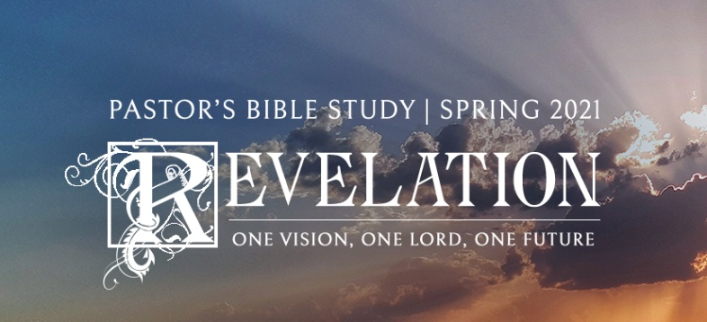

**Questions for Episodes 11 and 12**

January 6/7 and 13/14,

2021

1. What do you think of when you think of a "trumpet blast"?
2. What is most moving to you about wildfires, earthquakes, floods, hurricanes, and tornadoes?
3. What did the seven angels who stand before God prepare to do? (8:6)
4. What were the trumpet blasts that John heard? (8:7-8, 10, 12; 9:1, 13-15)
5. What happened when the first angel sounded his trumpet? (8:7)
6. What was the result when the second angel sounded his trumpet? (8:8-9)
7. What happened when the third angel blew his trumpet? (8:10-11)
8. What events followed the fourth angel's trumpet blast? (8:12)
9. What did John see an eagle do? (8:13)
10. What did John see at the sounding of the fifth trumpet? (9:1)
11. What creatures came out of the Abyss? (9:2-3)
12. What special powers did the creatures from the Abyss have? (9:4-6)
13. What significance is there to the plagues that will befall the world in the final days?
14. Why do you think the survivors in the last days will still refuse to turn to God-especially after seeing the horrible judgment all around them?
15. What does this passage tell us about God?
16. Why do you think so many of the plagues described here stop short of complete devastation?
17. After the first six trumpets of judgment, what did John see? (10:1)
18. What command did John receive from heaven? (10:4)
19. What unusual act was John asked to perform? (10:9)
20. What warning did the angel give John? (10:9)
21. What do you think is symbolized by John's eating the scroll of God's words and finding it sweet in his mouth and sour in his stomach?
22. In what situations has God's Word ever tasted sweet at first hearing but then sour as you "digested" it?
23. Who in your life has God called you to speak His truth to this week?
24. Why are some people so turned off by "fire and brimstone" type preachers?
25. What groups seem to you to be most opposed to the Christian message and to the spread of the gospel?
26. What important "end times" individuals are mentioned in this passage and what will be their mission? (11:3-6)
27. What special protection and powers will be given the ones called the "two olive trees and the two lampstands"? (11:4-6)
28. What will happen to the two witnesses when they have finished their God-ordained ministry? (11:7)
29. What catastrophic events will follow the two witnesses? (11:13)
30. What encouragement for Christians today does the story of the two witnesses offer?
31. Who is one famous and one not-so-famous Christian that you think will receive great reward in heaven? Why?
32. What group of people in addition to John heard the heavenly voices? (11:16)
33. Who did the elders describe as deserving a reward? (11:18)
34. Who did the elders describe as deserving destruction? (11:18)
35. What does the promise of both reward and judgment mean to you personally?
36. What does it say to us that even angels with awesome power and beauty and elders with great heavenly position worship God in total humility?