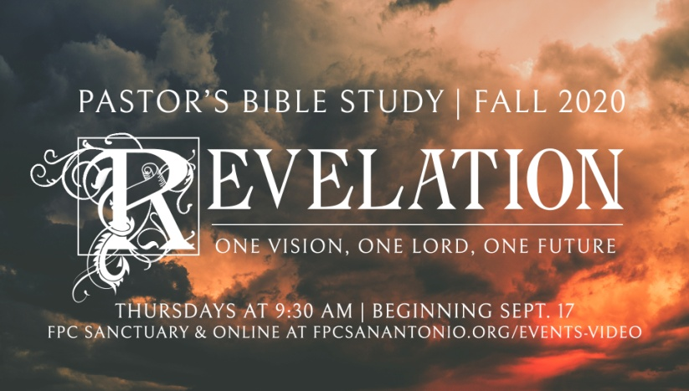

**Questions for Episode 9**

November 11/12, 2020

1. What is one natural disaster (earthquake, tornado, etc.) that stands out in your memory?
2. What happens in the opening scenes of this passage? (6:1)
3. What did John hear after Christ opened the first seal? (6:2)
4. What was the nature and the appearance of the first horse and its rider? (6:2)
5. What happened after the second seal was opened? (6:3)
6. How are the second horse and its rider described? (6:4)
7. What happened at the opening of the third seal? (6:5)
8. How did the voice that John heard explain the meaning of the scales in the hand of the third rider? (6:6)
9. What were the fourth horse and its rider like? (6:7-8)
10. What did John see at the opening of the fifth seal? (6:9)
11. What question did the martyrs ask God? (6:10)
12. What answer was given the slain ones? (6:11)
13. What happened at the opening of the sixth seal? (6:12-14)
14. How did the inhabitants of earth respond to the events unleashed by the breaking of the seals? (6:15-17)
15. How will people try to escape from being judged by God? (6:15-17)
16. How does reading this passage make you feel?
17. What do you think each of the four horsemen represents?
18. What do the judgments wrought by the horsemen have in common?
19. When do you think the judgments (represented by the four horsemen) will take place?
20. Why will God judge the earth?
21. Why do people try to escape from God?
22. Why do you think some people react so negatively to the message of Christ?
23. How long do you think God will wait before judging the earth?
24. What does God want us to do as we wait for Him to judge the earth?
25. How should we pray in light of the fact that God will judge all people?
26. How can you help a non-Christian friend or family member see his or her need for Christ?
27. How can you encourage a faithful Christian today who is being persecuted for following Christ?