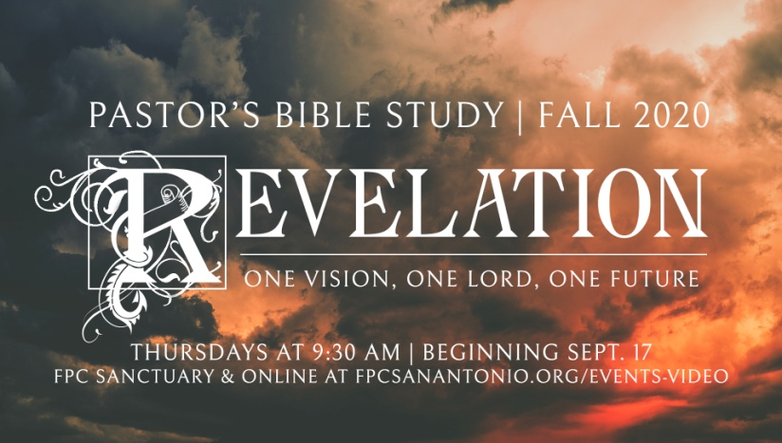

The Scroll, the Lion and the Lamb

Revelation 5:1-14

Episode 8

november 4/5, 2020

I**.** Review: The Worship of Heaven; 4:1-11

a. “Come up here:” John is “transported,” “raptured,” “beamed up,” “called up” to the heavenly throne room and witnesses the worship of Heaven.

b. The King on the Throne, the Four Living Creatures and the 24 Elders (24 Priests of the heavenly temple?)

c. Where is the High Priest? (He has not yet arrived.)

II. The Scroll

a. God’s plan for redemption: Whatever is in that scroll is the only hope for the world. God’s plan for saving the world. But………

b. Who is worthy to open it (carry it out? set it in motion?)

c. “4 So I wept much, because no one was found worthy to open and read the scroll, or to look at it.” (It’s hopeless, nobody can pull the sword from the stone.)

III. . The Lion and the Lamb

a. 5 But one of the elders said to me, "Do not weep. Behold, the Lion of the tribe of Judah, the Root of David, has prevailed to open the scroll and to loose its seven seals."

b. The Lion of Judah: Why is the Lion of Judah worthy?

i. David was of the house of Judah (God’s covenant with David).

ii.Why Judah? Judah’s Plea (Genesis 44:18- 45:1).

iii. Sacrifice - propitiation

c. Because the Lion of Judah **is** the Lamb who was slain (5:6)—Jesus Christ. He is worthy to break the seals.

IV. The Worship of the Lamb

a. Christ is worshipped because he is worthy.

b. The new song of the Lamb: Elders and the Four Living Creatures sing the Lead: (What the Lamb has accomplished).

1. "You are worthy to take the scroll, And to open its seals;

2. For You were slain, And have redeemed us to God by Your blood Out of every tribe and tongue and people and nation,

3. 10 And have made us kings and priests to our God; And we shall reign on the earth."

c. The Chorus of multitudes joins in the seven fold praise of the lamb…:

1. "Worthy is the Lamb who was slain To receive 1power and 2riches and 3wisdom, And 4strength and 5honor and 6glory and 7blessing!"

d. Then the whole universe joins in (v.13: And every creature which is in heaven and on the earth and under the earth and such as are in the sea, and all that are in them, I heard saying…)

1. "Blessing and honor and glory and power *Be* to Him who sits on the throne, And to the Lamb, forever and ever!"

2. Philippians 2:5-11 is fulfilled in Revelation 5.

3. 9 Therefore God also has highly exalted Him and given Him the name which is above every name,10 that at the name of Jesus every knee should bow, of those in heaven, and of those on earth, and of those under the earth, 11 and *that* every tongue should confess that Jesus Christ *is* Lord, to the glory of God the Father.

e. It Never Ends- The songs come together (one more time).

1. 14 Then the four living creatures said, "Amen!" Amen means “true,” not “over.”

2. And the twenty-four elders fell down and worshiped Him who lives forever and ever.