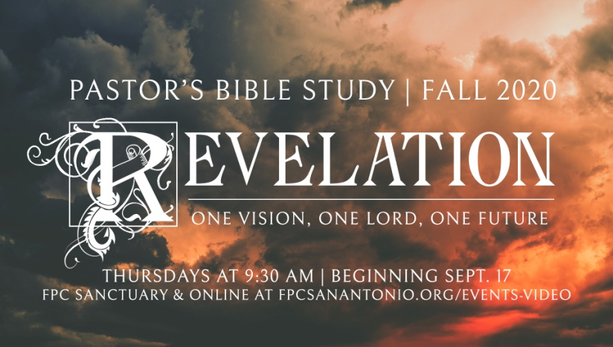

The Seven Seals, Part 2

Revelation 6:9-8:2

Episode 10

November 18/19, 2020

**The Seven Seals (Part 2)**

**I. Introduces One of Revelation’s Major Themes: The Tribulations or suffering of the earth and its inhabitants.**

a. Before Christ comes again, all of the earth both people and nature itself, will be subjected to disasters that can only be called catastrophic.

**b. There will be three series of seven disasters, and this period of suffering is called the *tribulation*.**

**c. The Tribulations are intended as God’s final wake-up call**.

**d. God’s redemption on the world begins with God’s judgments on the earth.**

**II. The First Four Seals: The Four horsemen.**

1. God's judgment on “Civilization”: *“The four horsemen present the picture of man’s inhumanity to man” (Tim Lahaye, Revelation Unveiled, 141).*
2. Taken in total: Antichrist begets War, War Begets Poverty (Scarcity, Famine), Poverty begets Disease and Death
3. All of these riders could have a specific historical referent. ­Rome, the Parthians, the end of the *Pax Romana*- a specific historic drought or plague following a war.
4. The important thing is that God's Judgment takes place even on the historic plane.
5. **The First Seal: The White Rider -- Spirit of Anti-Christ (6:1-2).**
6. **The Second Seal** **(6:3-4)**: **The Red Rider: War.**
7. **The Third Seal (6:5-6): The Black Rider: Poverty.**
8. **The Fourth Seal (6:7-8)**: **The Pale Rider: Death**.

**iII. The Fifth Seal - The Cry of the Martyrs (6:9-11).**

 a. “The Church is built on the Blood of the Martyrs.”

b. The number is yet incomplete - a number still alive (on earth).

c. “Rest a little while longer:” A Prelude to Justice.

d. This violent imagery is not a call to violence but a cry of desperation against the existing state of the world (status quo).

e. John wrote from an experience of suffering, but he wrote toward the promise of hope provided by the Lamb. This Christological perspective means that the reader must admit that the violent imagery cannot be taken without the prevalent image of Christ as the Lamb, as the one who was slain. The violent imagery does not exist apart from the victory of the cross and empty tomb, and without the hope of peace (7:13-17).

**iV. The Sixth Seal -** **The Upheaval of Nature and of Earthly powers (6:12-17).**

A. Human powers and authorities will be overthrown by “natural” disaster (vv 12-14).

B. The rich and the powerful will flee to their “bunkers,” hoping to find safety, but they cannot escape the wrath of the Lamb (6:15-17).

C. Will nature be judged as well? Since the fall, has nature run on a parallel track, unrecorded within the Bible?

*i. All creation awaits redemption: Rom. 8:18-23 I*

*ii. Luke 21:25ff*

*iii. There will according to the scripture be a great upheaval in the earth - of the Son of Man.* The created order will be redeemed as well. But it will go through an upheaval.

iv. “People will faint from fear and the powers of the heavens will be shaken." Luke 21:26.

*v.* Creation will be redeemed - Isaiah 11.

vi. What is evident in the passage is the sense that judgment will be played out in (or followed by) universal redemption of all creation (humans and nature) into a pre-fall state.

vii. Nature fell when human beings fell; our rebellion against God ruined the world. And so in the kingdom of God, when sin will be done away, the kingdom of nature will also be restored.

**v. Interlude: The 144,000 of Israel: The Jew First- Then the Greek? (7:1-17)**

a. What is the Seal? The imputed righteousness of Christ.

b. Are the 144,000 and the Gentiles the same people- does it all mean the church?

i. Traditionally, the 144,000 is the whole church, not just ethnic Jews but all Israel.

ii. My Proposal: The significance of the 144,000 and the "multitude" is in showing that at the end time God has not forsaken either the Jews or the Gentiles. He here shows the scope and unity and of God’s grace. The Jews have been "hardened" according to Romans, but not forsaken. Thus the seal is put "on them" (7:4). Contrasted with the great multitude, the Gentiles who profess Christ (by the Spirit) will be ***ingrafted*** into God's people.

c. All that we can know definitively is that Jew or Greek, only those who are the elect (those whose names are “written in the Lamb’s book of life from the foundation of the world…”; see 13:8; 17:8) are going to survive the tribulation and God's judgment. Everyone will be judged, but only those washed clean by the Blood of the Lamb and sealed with God's seal will survive.

**VI. The Seventh Seal: Silence, for about half an hour (8:1-2).**