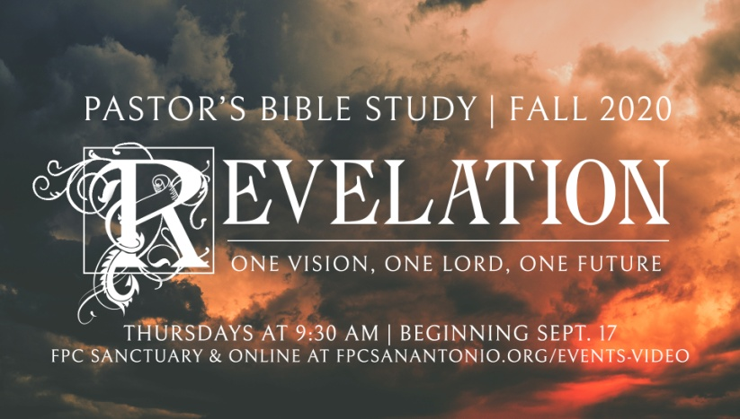

**Questions for Episode 8**

November 4/5, 2020

1. What was the biggest and most electric crowd of which you were ever a part?
2. What was in the hand of the one sitting on the throne in heaven? (5:1)
3. What loud proclamation did a mighty angel make? (5:2)
4. Who first came forward to open the scroll? (5:3)
5. What was John's reaction when the scroll could not be opened? (5:4)
6. What did one of the twenty-four elders say to John? (5:5)
7. Who was the only one worthy to open the scroll and its seals? (5:5)
8. What did the Lamb that John saw look like? (5:6)
9. Where was the Lamb that John saw? (5:6)
10. What did the Lamb do? (5:7)
11. How did the creatures around the throne respond to the actions of the Lamb? (5:8-9)
12. For what was the Lamb praised and worshipped? (5:9-10)
13. How many angels did John see? (5:11)
14. What were the angels doing? (5:12)
15. What were all the other living creatures doing and singing? (5:13)
16. Why do you think John was upset when nobody came forward to open the scroll?
17. Why do you think the prayers of the saints appeared as "golden bowls full of incense"?
18. What did Christ do for us?
19. What evidence do we have from this passage that God makes no distinction between races or ethnic groups?
20. Why should we value people of all races equally and treat everyone with equal respect?
21. What is the benefit of bowing down to worship God?
22. How can you worship God in your private times of prayer this week?
23. How can you develop an attitude of praise and thanksgiving to God as you go throughout your day?