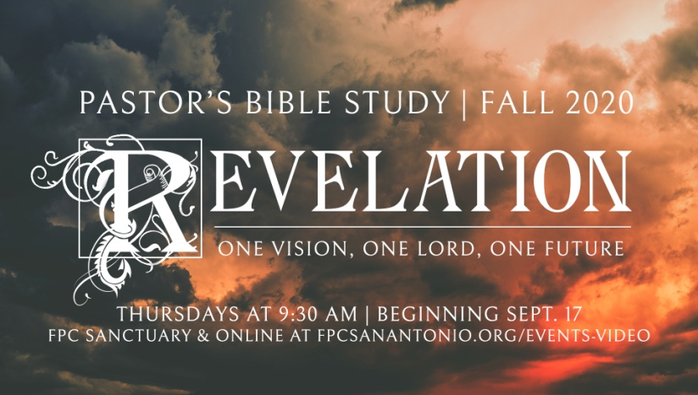

The Worship of Heaven

Revelation 4:1-11

Episode 7

October 28/29, 2020

I.A New Perspective (4:1-2)

a. “Come up here:” John is “transported,” “raptured,” “beamed up,” “called up” to the heavenly throne room to get a new perspective (Not a journey but an immediate happening [v.2]).

b. God wants to reveal to him the “things to come” but he will see them from heaven’s point of view.

c. John does his best to describe the indescribable.

II. The Throne Room of God

a. The Twenty-Four Elders

*i. Presbuteroi* (Greek) - “Elders,” “Presbyterians”

*ii. Twenty-Four* (24)

1. 2 x12 (12 is the number of heavenly government and organization).

2. There were 24 courses or orders of Priests in the Temple. The High Priest made 25. The Temple order on Earth reflected the order of heaven (Hebrews 8:1-5; vs. the abominations of Ezek. 8:16, 11:1). Christ, the High Priest (Hebrews 4:14) is 25.

iii. God’s Cabinet. Age here is a symbol of wisdom (knowledge and experience gained over time).

iv. Who are they? What do they represent?

1. Angels? Archangels?

2. The Church Triumphant? (Humans)

3. The Twelve Patriarch and Twelve Apostles?

4. Twelve Ancestors of Christ?

5. 24 Priests of the heavenly temple?

6. A new, previously unknown order of being altogether?

7. E.W. Bullinger: “Why is it necessary for us, when God tells us anything, to conclude that it means something else? Why, when in Revelation IV, we read *twenty-four* heavenly elders, are we to assume they are anything but what we read, viz., the leaders of heavenly worship? Why seek to make them redeemed men, or the symbolical representation of redeemed men? Why not leave them alone? It is by such additions as these to what is written that the people of God are divided up into so many schools and parties.”

v. Clothed in White: Purity of Purpose.

vi. Crowns of Gold:

1. Stand for *Authority*…

2. … and *Reward*. Time and time again, crowns are given as rewards for “overcoming” or doing a good job. Like a Laurel in the Olympics (spiritual achievement).

b. The Four Living Creatures (Seraphim?)

i. Four Foundations of the Throne

ii. Living Creatures: These were not statues of fictitious beasts (idols, Sphinx) - these are alive.

iii. Description (Compare to Isaiah 6:2 and Ezekiel 1:4-14).

1. 6 Wings: The Functional Anatomy of those who are daily in the presence of God. (Isaiah 6:2 - *“with two he covered his face, with two he covered his feet, and with two he flew.”*)

2. Faces

a. Attributes

i. lion - noblest

ii. ox - strongest

iii. human face - wisest

iv. eagle - ­swiftest

b. Realms of Creation

i. Lion - chief of the wild beasts

ii. Ox - chief of domesticated animals

iii. Human - chief of all “intelligent” life

iv. Eagle - chief of all flying things

c. Popular, but erroneous connection to the four gospels (four images of Jesus)

III. Worship: The Business of Heaven

a. The Worship of the Four Living Creatures (4:8)

i. “…And they do not rest day or night,

b. The Worship of the Twenty-Four Elders (4:10)

i. Falling down

ii. Casting their crowns before him

c. The Song of the Throne Room (One Song)

i. The chorus of the four living creatures: "Holy, holy, holy, is the Lord God Almighty, who was and is and is to come!"

1. Three Holies: Emphasis and Intensity.

2. God the Alpha and Omega - Connection to Chapter One (Same God).

ii. The chorus of the twenty-four elders: 11 "You are worthy, O Lord, to receive glory and honor and power, for You created all things, and by Your will they existed and were created."

d. The Incense / Lamp stands - The sacrifices and prayers of the faithful, rising up as a pleasant aroma before God.

e. *The Glassy Sea* - The laver of the Temple - the pool of purity and washing.

f. Where is the High Priest? (He has not yet arrived).