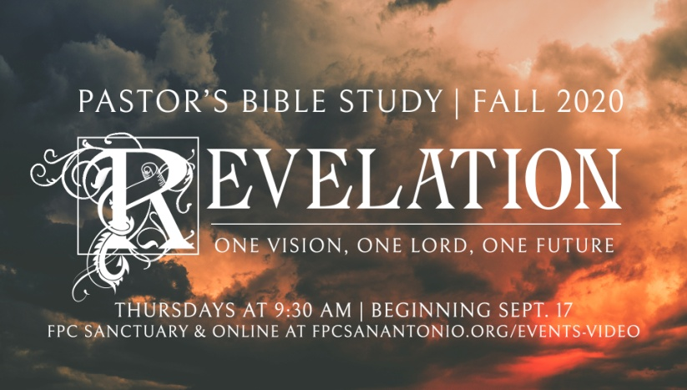

**Questions for Episode 7**

October 28/29, 2020

1. What does it mean to worship God?
2. What is a place or experience that is difficult for you to describe to others?
3. When and where was your most meaningful worship experience?
4. After receiving messages for the seven churches, what did John see? (4:1)
5. What did the voice John heard say to him? (4:1)
6. What incredible sights did John see? (4:2-11)
7. How did John describe the one sitting on a throne? (4:3)
8. What encircled or surrounded the throne? (4:3-4)
9. What came from the throne? (4:5)
10. What did John see in front of the throne? (4:5-6)
11. What kind of creatures were "in the center, around the throne"? (4:6-7)
12. How were the four living creatures around the throne similar? (4:8)
13. What attribute of God did the four living creatures praise again and again? (4:8)
14. How did the twenty-four elders worship the Lord God? (4:9-10)
15. Why did the elders say God was worthy of their worship? (4:11)
16. Why do you think God's throne figures prominently in the book of Revelation?
17. What attitudes do you think are expressed by falling down before God?
18. What impressions does this passage give you of God the Father?
19. What changes are you moved to make when you reflect on the holiness and majesty of God Almighty?
20. What reminders can you use this week to keep the reality and glory of God at the front of your mind?
21. How can you begin today to make praise and worship of God a more regular part of your life?