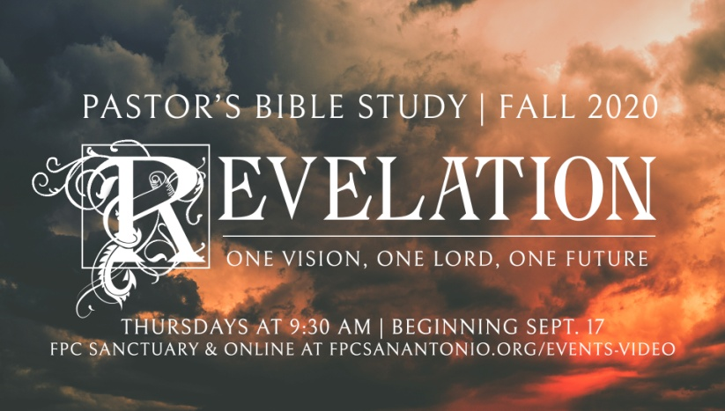

**Questions for Episode 6**

October 21/22, 2020

Choose **3** letters (only 3) and answer the questions in that set, and answer the last 3 questions.

**The Letter to Ephesus**

1. What church was the subject of this letter from Jesus? (2:1)
2. Jesus praised the church at Ephesus for what deeds? (2:2-3)
3. With what in the Ephesian church was Christ unsatisfied? (2:4)
4. What did Christ command the church at Ephesus to remember? (2:5)
5. What can cause us to lose our love for God?
6. What can you do or say to encourage a Christian friend to remain loyal to Christ?

**The Letter to Smyrna**

1. What is significant about the title Christ gave Himself ("the First and the Last, who died and came to life again")?
2. How can a person in poverty be considered rich?
3. In your view, which is worse -------- physical or verbal persecution? Why?
4. If you had been in Smyrna about to suffer for your faith, how comforted would you feel with this revelation from Christ?
5. What kinds of persecution do Christians face today?
6. What kinds of persecution do you think would most tempt you to deny Christ?
7. What kinds of persecution have you faced for your faith?
8. How can the eternal promises of God give us courage and strength in the face of attacks on our stand for Christ?

**The Letter to Pergamum**

1. What do you consider to be the most evil or sinful place on earth? Why?
2. What strange philosophy or common misconception (urban myth, old wives' tale, etc.) do you consider most dangerous? Why?
3. For what did Jesus praise the people of the church at Pergamum? (2:13)
4. What were the believers at Pergamum doing wrong? (2:14-15)
5. What command did Christ give to this church in light of its dangerous direction? (2:16)
6. What does it mean that Christ has a "sharp, double-edged sword"?
7. What should it mean to us that Jesus does not overlook sin, even if we are doing lots of good deeds?
8. What "little" sins do we tend to allow into our life-style and habits?
9. What does repentance have to do with following Christ?
10. How can we resist the influence of the world around us?

**The Letter to Thyatira**

1. For what did Christ praise the church at Thyatira? (2:19)
2. For what did Christ chastise the church at Thyatira? (2:20)
3. How did Christ show patience? (2:21)
4. What judgments did the Son of God pronounce on the one He called Jezebel? (2:22-23)
5. What two gifts were promised to "him who overcomes"? (2:26-28)
6. What are some things people make idols (gods) of today?
7. What sins do we tend to tolerate in our own lives or in the lives of our Christian friends when we should not?
8. What dangers do we face when we refuse to respond to God or repent of our sins?
9. How can you include repentance and renewal in your devotional life this week?

**The Letter to Sardis**

1. What was the reputation of the church at Sardis? (3:1)
2. How did the church's true nature match its reputation? (3:1)
3. What was wrong with the church at Sardis? (3:2)

1. What did Christ urge as the first step to restoration? (3:3)
2. What do you think is your reputation among your coworkers? Neighbors? People at church?
3. How can a church appear to be alive and thriving and yet be dead?
4. What does it mean to "overcome" as a Christian?

**The Letter to Philadelphia**

1. What did Christ say about His power? (3:7)
2. What humbling act did Jesus say He would force the enemies of the church of Philadelphia to perform? (3:9)
3. What worldwide event was predicted by Christ? (3:10)
4. What was promised to the church at Philadelphia because of its patient endurance? (3:10)
5. How did Jesus instruct the believers in Philadelphia to prepare for His coming? (3:11)
6. What do you think about the idea that the world is getting better and better?
7. What can we do to prepare for Christ's return?
8. Where can you go for the encouragement you need to keep walking with Christ in a hostile world?

**The Letter to Laodicea**

1. How did Jesus describe the church at Laodicea? (3:15)
2. What response did Jesus promise to the Laodicean church because of its behavior? (3:16)
3. What is the nastiest food or drink you ever tasted?
4. In what ways was the Laodicean church deceived? (3:17)
5. What reason did Jesus give for His stern warnings? (3:19)
6. What do we know about the Laodicean Christians from the fact that Jesus described Himself as being outside the door?
7. What does it mean that Jesus "stands at the door and knocks"?
8. What is a hot Christian, a cold Christian, or a lukewarm Christian?
9. In what ways can a person be religious yet indifferent to what God wants?
10. How much stock do we tend to put in our own resources (especially money and things)?
11. What is the significance of the phrase, "He who has an ear to hear, let him hear . . . " at the end of each of the letters to the churches?

**Bonus Questions**

1. If Jesus were to write a letter to your church, what do you think He'd say?
2. If Jesus were to write you a personal letter, for what would He commend you, and in what ways would He correct you?
3. Which of the seven churches described in Revelation 2:1-3:22 are you most like? Why?