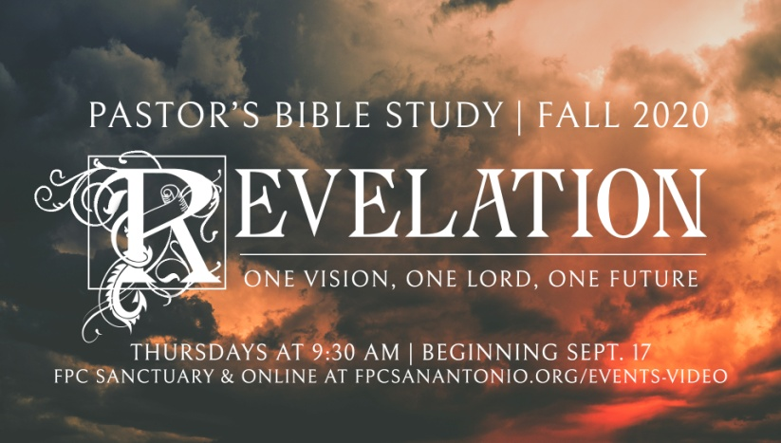

**Questions for Episode 5**

October 14/15, 2020

1. With what typical phrases do you open and close your letters?
2. To whom did John write this letter? (1:4)
3. How did John refer to God? (1:4)
4. How did John greet his readers in Christ's name? (1:4)
5. What does grace mean to you?
6. What does the peace of God look like in our lives?
7. By what threefold description is Jesus presented? (1:5)
8. What is Jesus' attitude toward Christians? (1:5)
9. What does Jesus do on behalf of Christians? (1:5)
10. In what way does Jesus make all believers new? (1:6)
11. What is Jesus' purpose for the church? (1:6)
12. How did John react when he recounted all the things that Jesus had done for Christians? (1:6)
13. What prophecy opens this book? (1:7)
14. By what unique description does God explain Himself in this passage? (1:8)
15. What does it mean that God is the "Alpha and Omega"?
16. What does the description, "him who is, and who was, and who is to come," tell us about God? (1:4)
17. How might you explain to a friend the concept that God is "Almighty"?
18. What changes need to take place in your life to reflect the truth that Jesus may return at any moment?