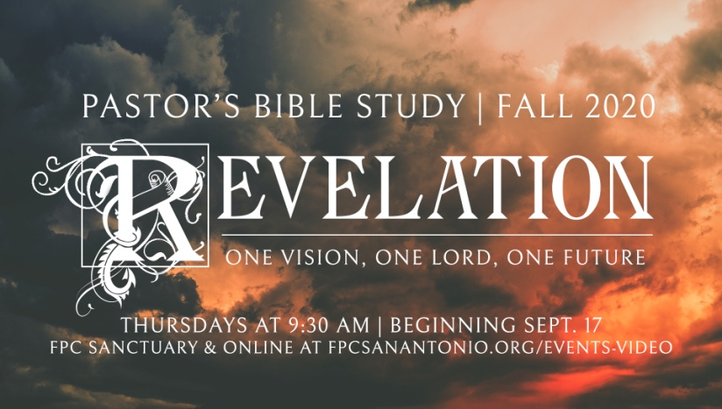

John’s First Vision

Revelation 1:9-20

Episode 5

October 14/15, 2020

**I. John’s First Vision (1:9-16)**

1. John introduces his first vision by telling his readers that he was on the island of Patmos because he had proclaimed God's message and the truth that Jesus revealed. Patmos was a political prisoners’ penal colony.
2. But John also identifies himself as the reader’s companion in ***the*** tribulation (specific).
3. John is writing in the *past tense*. In other words, he is writing about what he *saw* in his vision.
4. “One like” is an indication that this is a figurative or symbolic statement.
5. "I am the Alpha and the Omega, the First and the Last": Identifies Christ with God. The same yesterday, today and tomorrow (NKJ Hebrews 13:8 Jesus Christ *is* the same yesterday, today, and forever.).
6. Calls the seven churches by name (like a teacher trying to get the attention of a little child).
7. Compare to Daniel 7:9; 10:5-6.
8. John says he saw Jesus in the midst of the lampstands because he wants to let us know that he is not an absentee landlord. – M
9. The description is taken from Daniel (7:9) where the prophet describes his vision of God, the Ancient of Days. In this way, John assigns a dignity to Christ in terms that resemble Daniel's vision of God almighty.
   1. **Piercing eyes "like a flame of fire**" burn away our shame and hypocrisies, looking into our inmost selves.
   2. "**Feet like burnished bronze**" represent strength and stability (contrast Dan. 2:33, 41).
   3. Voice of Christ **"like the sound of many waters,"** words that the prophet Ezekiel used to describe the God of Israel (Ezek. 43:2).
   4. The meaning of the **seven stars** that Christ holds in his right hand is explained at the end of the chapter; they "are the angels of the seven churches" (1:20).
   5. The **Sword** that comes from his mouth symbolizes his word of judgment (see Heb. 4:12).
   6. Finally, John says that the **face of Christ is like “the sun shining with full strength**."

**II. John’s reaction to the vision and Christ’s Reassurance (v. 17)**

1. Compare to Daniel’s reaction in Daniel 10:8 ff and Isaiah 6.
2. In all cases the witness “melts” or disintegrates before the Holy one.
3. But Christ comforts and restores (puts his hand on him).
4. “I am the First and the Last”: Words of comfort in troubled times.

**III. John’s First Vision Continues**

1. The living one (who) was dead, one who lives for ever and ever, the holder of the keys to death and Hades**:** Recognition of the Easter perception of John's readers of the Resurrected Jesus and his subsequent dominion over death and the final Judgment (1:18, 2:8, 11:18, 14:13, 16:3, 20:5, 20:12-13).
2. **Holder of the two-edged sword: (v.16) The word of truth.** The Interpreter's Commentary suggests that the sword identifies Jesus as one who smites his foes and a judge who annihilates with his sentence. This image of Jesus portrays him as Judge and warrior.

**IV. John’s Commission and the explanation of the mystery (VV. 19-20)**