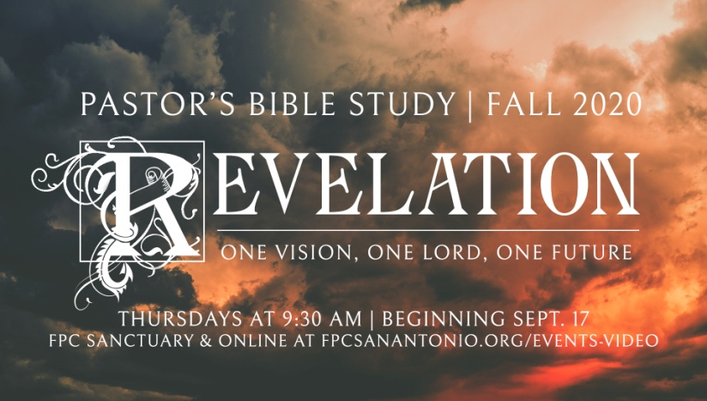

Chapter 1: Prologue

Episode 4

October 7/8, 2020

**I. Preliminary Considerations**

a. Ultimately, Revelation is not about us. It is about giving God glory for who He is (and who Christ is), What He has done, What He will do.

i. Theology - literally, words about God

ii. Christology – literally, words about Christ

b. We will try to be faithful to a literal interpretation except where the text gives us permission not to be.

**II. Introduction and Benediction** (vs.1:1-3)

a. In the opening prologue of the book, John discloses to the reader the origin and content of his book. - M (Hereafter, a capitol letter M is used to indicate quotes or notes from *Breaking the Code*, by Bruce M. Metzger)

b. The source of the revelation is God, who speaks through the Son.

c. Timing Issue - things which must shortly take place. The things which must shortly take place (imminent- not suddenly) The “Time is Near” (verse 3).

d. Blessed (*makarios*) same word used in the Beatitudes.

e. The material in the book of Revelation is so important that a blessing is promised to the one who reads it aloud and to those who hear it and who keep what is written in the prophesy.- (M) A promise of hope. Revelation not only prophesies judgment on the faithless, it also promises blessing on the faithful.

f. John calls his book prophesy; it has the weight of the words of the Old Testament prophets.

g. the Time (Kairos = time, event, appointed hour,*moment of truth***)** is near (eggus = near, close, on the verge of happening, *imminent*, about to pop, etc.)

**III. Salutation to the Seven Churches** (v. 4)

1. The immediate recipients are the seven churches in Asia, which are as yet unnamed.

b. Seven is the number indicating completeness - M so seven churches = "all the churches."

c. EW Bullinger: “Sheva” - - from “Savah” (sabah) the same root as “Sabbath.”

d. Grace to you and peace - Common Greeting of the Early Church.

e. Him who is and who was and who is to come… Reference to God the Father.

f. Seven Spirits: Possibly a reference to the Holy Spirit in His completeness. Isaiah 11:2 (The Spirit

of the LORD1 shall rest upon Him, The Spirit of wisdom2 and understanding3, The Spirit of

counsel4 and might5, The Spirit of knowledge6 and of the fear of the LORD7.)

**IV. The Theology of Revelation 1**

1. "God is the ultimate source of the revelation. The word that is heard in Revelation is ultimately the word of God” (v.2)
2. John's theology is thoroughly theocentric. “As in Genesis 1:1 the first active verb in the sentence has God for its subject, the God who is the hidden actor throughout." (Eugene Boring, Revelation: Interpretation Commentary, p. 65)

(v. 8) **I am** the **Alpha and the Omega…,** say the Lord God, **the one who is and who was and the one who is coming, the Almighty.**

• The combination ( **ego eimi- “I am”)** is used some 19 times in Revelation and is employed by both God and Jesus. **The one who is and who was and the one who is coming** is probably an expansion of God's name found in Exodus 3:14 , "I am who I am." (INT, Harper's) This extended version of Yahweh (“I am”) was familiar to the Hellenistic (Greek) Judaism in both Egypt and Anatolia. Just as Moses is told to tell the people of Israel that "the one who is" had sent him, so John legitimates his claim to write by using it.

• The divine name **"Alpha and Omega" (First and the last; A and Z)** was drawn from from Hellenistic Revelatory magic where it abbreviated the seven Greek vowels which were widely believed to constitute the name of the highest god.

• **The The one who is and who was and the one who is coming** combines Jewish and Hellenistic divine names. _"I am" + (A +)

• **"The Almighty"** is borrowed from Judaism- It is a title used by John to draw a contrast later between God and Satan and uses the titles for both Jesus and God. (Aune, Harper's)

(v. 8) **I am** the **Alpha and the Omega…,** say the Lord God, **the one who is and who was and the one who is coming, the Almighty.**

• The combination ( **ego eimi- “I am”)** is used some 19 times in Revelation and is employed by both God and Jesus. **The one who is and who was and the one who is coming** is probably an expansion of God's name found in Exodus 3:14 , "I am who I am." (INT, Harper's) This extended version of Yahweh (“I am”) was familiar to the Hellenistic (Greek) Judaism in both Egypt and Anatolia. Just as Moses is told to tell the people of Israel that "the one who is" had sent him, so John legitimates his claim to write by using it.

• The divine name **"Alpha and Omega" (First and the last; A and Z)** was drawn from from Hellenistic Revelatory magic where it abbreviated the seven Greek vowels which were widely believed to constitute the name of the highest god.

• **The The one who is and who was and the one who is coming** combines Jewish and Hellenistic divine names. _"I am" + (A +)

• **"The Almighty"** is borrowed from Judaism- It is a title used by John to draw a contrast later between God and Satan and uses the titles for both Jesus and God. (Aune, Harper's)

(v. 8) **I am** the **Alpha and the Omega…,** say the Lord God, **the one who is and who was and the one who is coming, the Almighty.**

• The combination (**ego eimi- “I am”)** is used some 19 times in Revelation and is employed by both God and Jesus. **The one who is and who was and the one who is coming** is probably an expansion of God's name found in Exodus 3:14, "I am who I am." (INT, Harper's) This extended version of Yahweh (“I am”) was familiar to the Hellenistic (Greek) Judaism in both Egypt and Anatolia. Just as Moses is told to tell the people of Israel that "the one who is" had sent him, so John legitimates his claim to write by using it.

• The divine name **"Alpha and Omega" (First and the last; A and Z)** was drawn from Hellenistic Revelatory magic where it abbreviated the seven Greek vowels which were widely believed to constitute the name of the highest god.

• **The one who is and who was and the one who is coming** combines Jewish and Hellenistic divine names. "I am" + (A +)

• **"The Almighty"** is borrowed from Judaism - It is a title used by John to draw a contrast later between God and Satan and uses the titles for both Jesus and God. (Aune, Harper's)

**V. The Christology of Revelation 1**

**a. Who He is, what he has done, What he will do (vv. 1:5-7)**

i. **Who He is:**

1. God’s faithful witness

2. The firstborn from the dead

3. Ruler of the kings of this earth

4. The Alpha and the Omega

5. The Eternal One

ii. **What He has done:**

1. Shed his blood to redeem us

2. Made us a kingdom of priests

**iii. What He will do (He will come again in the clouds):**

1. Revealing himself to the Jews

2. Revealing Himself to the Gentiles

3. Every eye will see him, even they who pierced him (both Jews and Gentiles because both had a hand in his crucifixion. And all the tribes of the earth will mourn because of Him (“Oh no, what have we done!?”)

4. His second coming will correct the world’s folly represented in John 1:10-11 (NKJ John 1:10 He was in the world, and the world was made through Him, and the world did not know Him. 11 He came to His own, and His own did not receive Him).

b. "The Christology of Revelation is expressed in images, not in concepts." (ABD)