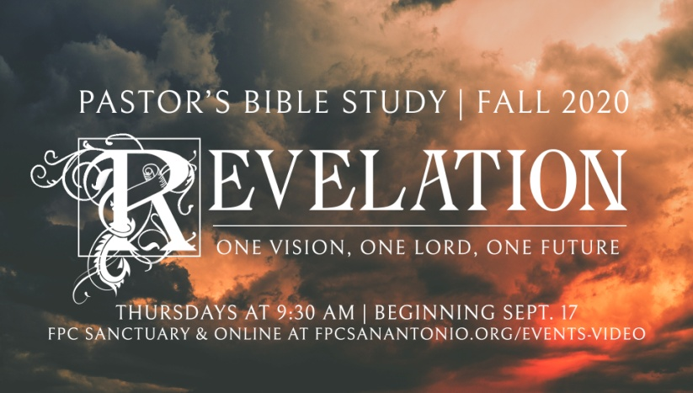

**Questions for Episode 3**

October 1, 2020

1. What is the strangest dream you have ever had?
2. What outlandish predictions about the future have you heard at one time or another?
3. Why do you think people are often interested in studying the book of Revelation?
4. What did John call his writing? (1:1)
5. What did God want us to learn from the book of Revelation? (1:1)
6. What is promised to those who take the time to study this revelation? (1:3)
7. What did John urge his readers to do? Why? (1:3)
8. In what way does this "revelation of Jesus Christ" reveal Jesus to us?
9. What does it mean to "take to heart what is written"?
10. How does it make you feel to realize that God wants us to know what the future holds?
11. What are some ways God might bless us through a study of Revelation?
12. What is the overall message of the book of Revelation?
13. What are the five (5) major themes of Revelation?
14. For Group Discussion: Name and describe the five (5) major themes of Revelation.