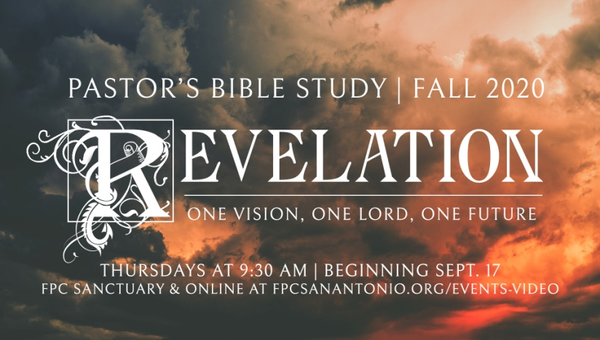

**“Rightly (and wrongly) Dividing the Word of Truth”**

Episode 2

September 24, 2020

1. The Revelation of John is a controversial book (The two most controversial books of the Bible—Revelation and Genesis).
2. REVIEW
   1. WHAT KIND OF BOOK IS REVELATION? APOCALYPTIC PROPHECY
   2. TWO KEY INTERPRETIVE CONTROVERSIES: Timing and Symbolic Interpretation. “Why do we read Revelation differently?”
      1. Timing: The Revelation 1:19 Problem:
         1. Revelation 1:19 in which Jesus says to John, “W*rite the things which you have seen, and the things which are, and the things that will take place after this.”*
         2. Did some of the events described in the book of Revelation already happen in the first century, during John’s life?
         3. Will some of the prophecies be fulfilled in the future?
         4. Are some of the tribulations of Revelation coming to pass now?
      2. Symbolic Interpretation
         1. “Literal” vs. “Literary”: John’s use of symbolic language
         2. “Mythic” Language: A new definition of “Myth”
         3. Example: How would a prehistoric person describe a jet airplane, or a submarine, or a helicopter?
         4. What are the antecedent realities behind the symbols of Revelation?
3. INTERPRETATION OF THE BOOK HAS TENDED TO FOLLOW FOUR COURSES
   1. *Historicist:* Calvin, Luther, Wesley et. al- Revelation covers the whole of Christian history, and we are somewhere in it. Ex. the Pope is the Antichrist. Problem is that they can't agree on what = what.
   2. *Preterist:* Everything written took place in or near the time Revelation was written. Prophesy as "forthtelling" (describing the writer’s current environment) as opposed to “foretelling” (telling the future). Liberal – historical, critical, academic. Problem is Revelation is only valuable as a historical resource. Locked in time, no message for us today.
   3. *Futurist:* Hal Lindsay et al. - most popular- Literal interpretation of symbols. Everything in Revelation will happen just before the return of Christ. Premillenial, Post millennialism
   4. *Symbolic:* Transcendent - The images and struggles represent spiritual realities unbound by time. The state of spiritual warfare. The "State of the Universe Address." Problem- not as much intersection with real history, but it honors the inspired transcendent word of Scripture.
   5. Ignore it altogether-most common
4. *REFORMED* *(COVENANT THEOLOGY)* VS *DISPENSATIONALISM*

###### What is Dispensationalism? Where does it come from?

* 1. Dispensationalism is an approach to biblical interpretation which states that God uses different means of working with people (Israel and the Church) during different periods of history, usually seven chronologically successive periods. A dispensation is, basically, a period of time that is distinguished from another period of time. However, the dispensational division of history varies among its adherents but seven is the most common.
  2. Dispensational Core Beliefs
     1. Literal interpretation of the Bible
     2. God works via different arrangements in distinct periods of history
     3. Israel is the literal descendants of Abraham, not spiritual ones
     4. Israel is the heir to the promises made to Abraham about the seed being blessed
     5. Participation in the Abrahamic Covenant is “mainly” by physical birth in Jewish lineage
     6. Two distinct people groups:  Israel and the Church
     7. Church began at Pentecost
     8. Salvation is by faith in accordance to the revelation given in a particular dispensation
     9. The Holy Spirit did not indwell people in all dispensations, only during the dispensation of the Church Age
  3. What do Dispensationalists teach about Revelation? In a nutshell…
     1. That the Bible teaches a rapture of the church before the beginning of a great seven-year tribulation.
     2. During this tribulation period, the Jewish nation will be converted to Christianity and the Anti-Christ will appear.
     3. Following a brief period of world peace, the Anti-Christ will instigate an intense persecution of the Jews, culminating in the final battle of Armageddon in the land of Israel.
     4. At the height of the battle, Christ will return to establish a visible, earthly kingdom with Jerusalem as its capital.
     5. All Christ's enemies will be defeated by the rod of Christ's power and the heathen nations held in check for a thousand-year millennium.
     6. During this time the sacrificial worship rituals of the temple in Jerusalem will be restored, though performed in a Christian spirit.
     7. At the end of this thousand years, Satan will be unleashed for a brief period of time, until Christ subdues him once again.
     8. Following this there will be the resurrection of the wicked and their judgment before the throne of God. A new Heaven and new Earth will be created and the eternal realm will begin.

1. Presbyterian points of difference:
   1. Covenant Theology
   2. Covenant theology centers on one overall covenant known as the *covenant of grace*. Some have called it the *covenant of redemption*. (Prior to that was the Covenant of Works)
   3. This covenant of grace is being worked out in history on earth through subordinate covenants, beginning with the covenant of works and culminating in the new covenant, which fulfills and completes God’s work of grace to man on earth. These covenants include the Adamic covenant, Noahic covenant, Abrahamic covenant, Mosaic covenant, Davidic covenant, and new covenant.
   4. Covenant theology does not see each covenant as separate and distinct. Instead, each covenant builds on the previous ones, including aspects of the previous covenants and culminating in the new covenant in the person and work of Jesus Christ over all history.
   5. The Rapture
      1. A pre-tribulation rapture of the church has never seemed warranted by Scripture to Reformed theologians. Orthodox Presbyterian Theology teaches endurance in tribulation, not escape from it.
      2. God does not have separate salvation plans for Jews and Christians- for “Nation Israel” and the Church.
      3. The pre-tribulation rapture of the church is an almost necessary ingredient of dispensational theology, so that the destinies of Israel and the church will not intertwine.
      4. Dispensationalists believe that all the Old Testament promises to Israel will find literal fulfillment in a future nation of Israel. John Calvin and other reformed theologians believed that the unfulfilled promises to Israel were transferred to the church after the coming of Christ and will be fulfilled in a spiritual manner.
      5. Dispensationalists see a literal millennial Jewish kingdom established in Palestine. Our Reformed tradition believes that there is now and forever only one people of God, the Church, made up of Jews and Gentiles, with Christ as its Head. Our tradition believes that Dispensationalism erroneously creates two people of God, the Jews and the church, with two separate destinies.
   6. The Return of Christ
      1. Orthodox / Presbyterian tradition also believes that Dispensationalism erroneously creates two returns of Christ, one a secret coming of Christ "for" his saints, and the other a visible coming of Christ "with" his saints.
      2. The Scriptures, as our church has interpreted them, always point toward one return of Christ that will be swift, complete and unexpected when it occurs.
   7. Contextual Reading of Scripture
      1. Dispensational theology has a strong tendency of forcing texts to fit its system without taking their original meaning and context into account.
      2. Reformed theology has generally felt less compelled to reconcile every detail of our end-times theology into a coherent system and thus is less tempted to try to align every text. We acknowledge that there are certain matters that we will not understand until they come to pass and that remain part of the hidden mysteries of God.