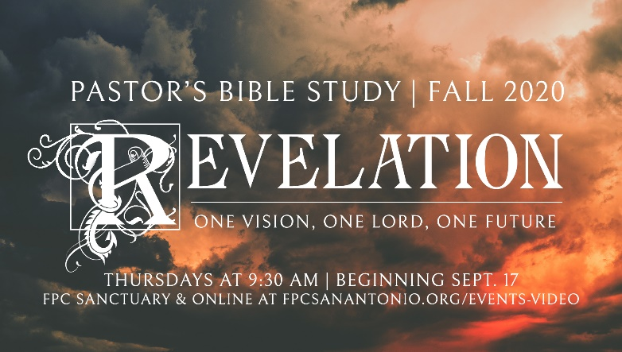

**Questions for Episodes 1 and 2**

September 17 - 24, 2020

**Questions for Episode 1: “Not For Beginners”**

1. Define “Eschatology.”
2. Define “Parousia.”
3. Define “Apocalypse.”
4. Why are people interested in the future?
5. How do you react when you hear predictions about the end of the world?
6. How does talk of the end times motivate us to live a holy life?
7. In what ways can we become sidetracked by discussion of the end times?
8. How can talking about God's promises for our future encourage us in our daily lives?
9. What can you do to make sure you are ready for Christ's return each day?
10. What hope can you share with someone who is convinced that death is the end of our existence?

**Read Daniel 7**

1. God revealed Himself to Daniel through dreams and visions. How does God usually speak to us today?
2. How does Daniel's vision portray God's control in the affairs of the world?
3. To whom does God hand over the dominion of the world?
4. What occurred when the "son of man" was before the Ancient of Days? (7:13-14)
5. When did the Lord speak to the prophet Zechariah? (1:1)

**Read Zechariah 1**

1. What word from the Lord did Zechariah bring to Israel in his call to repentance? (1:1-6)
2. What did the horsemen report in the first vision? (1:7-11)
3. What was the Lord's response in the first vision? (1:14-17)
4. How did the Lord explain the vision of the four horns and four craftsmen? (1:18-21)

**Questions for Episode 2: “Rightly (and Wrongly?) Dividing the Word of God.”**

1. Describe some of the differences between Reformed and Dispensational interpretations of Revelation.
2. What do the popular press and culture say about the immediate and long-range future of planet Earth?
3. What four courses has the interpretation of Revelation followed?
   1. H______________
   2. P______________
   3. F_______________
   4. S_______________

**Matthew 24**

1. As Jesus was sitting on the Mount of Olives, what questions did the disciples pose? (24:3)

1. How is it helpful that Jesus didn't give us a specific time or date for His return?
2. What signs do you see that we may be close to the beginning of the end?
3. How could you use this passage to talk to a nonbeliever about Jesus Christ?
4. In what specific ways does this passage encourage you to pray?

**I Thessalonians 4:13-5:11**

1. How do you react when you hear predictions about the end of the world?
2. Why is the date and time of Christ's Second Coming of such interest to many people?
3. What influence should the promise of Christ's Second Coming have on how a person lives day to day?