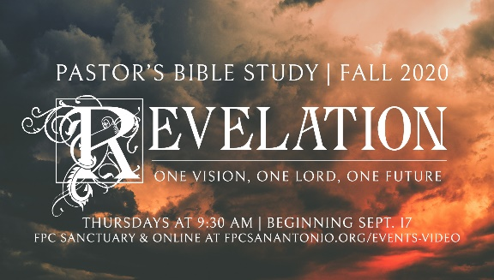

**Not For Beginners**

Episode 1

September 17, 2020

*“Write the things which you have seen, and the things which are, and the things that will take place after this.”*

-Revelation 1:19

1. ***“It’s the end of the world as we know it…and I feel fine!”-*** Michael Stipe, Mike Mills and Peter Buck, R.E.M.
   1. Why study Revelation now? Is 2020 the end of the world?
   2. Is Revelation about the End of the World?
   3. The Sovereignty and Victory of God, Daniel 7:9-12
   4. The Present Reality of Christ, Daniel 7:13-14
2. WHY “NOT FOR BEGINNERS?”
   1. Not like other (all) other books
   2. Not for Beginners, but necessary for all of us
3. WHAT IS ESCHATOLOGY
   1. *Eschatology* means _____________________________.
   2. *Parousia* means________________________________.
4. WHAT KIND OF BOOK IS REVELATION? APOCALYPTIC PROPHECY
   1. APOCALYPTIC:  *Apocalypse* means *_____________________.*
   2. NKJ Revelation 1:1 “The Revelation of Jesus Christ, …” Apocalypse: Revelation
   3. Daniel (and is seen in Isaiah, Ezekiel, and Zechariah).
   4. Ecstatic dreams or visions, which are reported in the stylistic features typical of apocalyptic literature. (symbols, colors, dates, etc.)
   5. Although no formal laws are applicable to all revelations (apocalypses), most of these books have common features:
      1. Dualism - Cosmic struggle between good and evil, behind the struggle are supernatural entities- God and Satan
      2. Eschatology - end of present age and coming of new age
      3. New age arrives only by supernatural intervention
      4. Pessimistic about present - optimistic about future
      5. Present Age (Evil) => Messiah <= New Age (Good) 3) Symbols
      6. Terrifying Beasts (to match terror of persecution)
      7. Numerical symbolism (2-division, 3-spiritual, 4-earth, 7-perfect, 10-complete/power, 12-church)
      8. Colors (red, black, white, gray, gold)
      9. See Zechariah 1:7-21
   6. …PROPHECY
      1. John is both a *forthteller* and a *foreteller*.
         1. The Prophet’s warning and promise
         2. Zechariah and Revelation’s Seven Churches (Zechariah 1:1-6)
      2. Revelation borrows heavily from the imagery and prophecy of the Old Testament. Of the 404 verses in Revelation, 278 allude to the Old Testament (though not one direct citation is actually quoted).
5. TWO KEY INTERPRETIVE CONTROVERSIES: Timing and Symbolic Interpretation. “Why do we read Revelation differently?”
   1. Timing: The Revelation 1:9 Problem:
      1. Revelation 1:19 in which Jesus says to John, “Write the things which you have seen, and the things which are, and the things that will take place after this.”
      2. “Did some of the events described in the book of Revelation already happen in the first century, during John’s life?”
      3. “Will some of the prophecies be fulfilled in the future?”
      4. “Are some of the tribulations of Revelation coming to pass now?”
   2. Symbolic Interpretation
      1. “Literal” vs. “Literary”: John’s use of symbolic language
      2. “Mythic” Language: A new definition of “Myth”
      3. “It is not a question of falsehood, but of a truth that can only be expressed by picture language and imagery.”
      4. …We use the word “Myth” not in the sense of unhistorical, but to denote that which is beyond history. …when we speak of events outside the realms of our normal space-time complex, we simply cannot avoid using language in a metaphorical, analogical way… (-Paraphrased, James D.G. Dunn, Interpretation. Jan 1997, 46-47)
      5. Example: How would a prehistoric person describe a jet airplane, or a submarine, or a helicopter?
      6. What are the antecedent realities behind the symbols of Revelation?
6. Introductory examples of Apocalyptic Literature from the Bible
   1. Daniel 7
   2. Zechariah 1
7. Overview of the Course