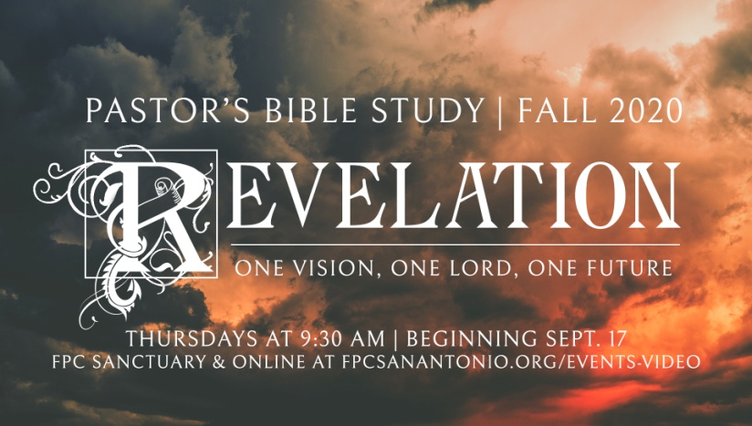

The Seven Seals, Part 1

Revelation 6:1-8

Episode 9

November 11/12, 2020

1. **Introduces One of Revelation’s Major Themes: The Tribulations or suffering of the earth and its inhabitants.**
2. Before Christ comes again, all of the earth, both people and nature itself, will be subjected to disasters that can only be called catastrophic.

1. **There will be three series of seven disasters, and this period of suffering is called the *tribulation*.** The tribulation will include world war, famine, disease, earthquakes, fire, hail and painful spiritual attacks. People will die by the billions. But the sufferings of the great tribulation will not be sent upon the earth because God is mean or capricious.

1. **The Tribulations are intended as God’s final wake-up call**. Very often it takes personal tragedy to make somebody turn to God. Perhaps that tragedy comes in a time of war, or death, or disease or natural disaster. It is God’s version of tough love, meant to get the attention of those who believe they do not need him, as if he is saying, “If you don’t think you need me, see what happens when I remove my protection.” Tragically, there will be those who will not turn to him, even in the face of undeniable proof, and they will suffer without hope. But the good news is that Revelation tells us over and over again that there are many who will indeed get the message and turn to Christ, and live eternally.

1. **God’s redemption on the world begins with God’s judgments on the earth.**

i. “From chapter 6 to the end of Chapter 11 is intended to bring before the reader not only the struggle of the Church amid conflict and persecution, but also the judgments of God upon the church's enemies.”-M

ii. Power rightly understood belongs to God. John begins with the belief that all power comes from God. God is the absolute ruler of the world, but because God gave humankind free will, there is always the possibility that we might misuse the portion of power entrusted to us. When this happens, however, it does not mean that God is helpless and frustrated. The world is still God's world, and is still ruled in accordance with the eternal laws of right and wrong. The way that God's power is manifested in the world is that the misuse of power brings on suffering and disaster. Wars, starvation, devastation- these are the means by which it is made plain that power abused is still under God's control. These are the "judgments" of God being worked out in the plane of History.

iii. You want it, you've got it. The judgment for sin is sin, a la Romans 1. Civilization will reap what it has sown. During the time of tribulation, those who do not turn to God for salvation will seek help from a counterfeit savior. During the calamities that precede the return of Christ, a person will rise who is called variously the Beast, or the Antichrist. The Antichrist will appear as a human being who shall restore peace and order, and will promise happiness and prosperity once again. But he is a liar. In every way, he will be a counterfeit Christ, who blasphemes the one true God and drives people farther and farther away from real salvation.

**The Seven Seals**

1. **The First Four Seals: The Four horsemen-**

a. God's judgment on “Civilization”: *“The four horsemen present the picture of man’s inhumanity to man. They seem to be a divine prediction of the affairs of humankind that will cause much human suffering. This is not new, for those in control of the affairs of this world have a history of causing their fellow human beings much suffering, with false hopes of peace followed by wars, famines and death.”(Tim Lahaye, Revelation Unveiled, 141.)*

b. Taken in total: Antichrist begets War, War Begets Poverty (Scarcity, Famine), Poverty begets Disease and Death.

c. All of these riders could have a specific historical referent. ­Rome, the Parthians, the end of the *Pax Romana*- a specific historic drought or plague following a war.

d. The important thing is that God's Judgment takes place even on the historic plane.

**III. The First Seal: The White Rider -- Spirit of Anti-Christ (6:1-2)**

a. The Ambition of a would-be ruler/ world leader. A counterfeit “king of kings.”

b. Authority based on conquest (compare to the Lamb who was worthy in chapter 5).

i. Bow – War.

ii. Crown (authority/achievement).

iii. It begins: Daniel 9:27, a false “Messiah” will make a covenant with Israel. (Daniel 9:27 Then he shall confirm a covenant with many for one week; But in the middle of the week He shall bring an end to sacrifice and offering. And on the wing of abominations shall be one who makes desolate, even until the consummation, which is determined, Is poured out on the desolate.")

iv. This is earthly power, built upon conquest. It is pure looking (white) and appears to have power (crown), but the bow and its words proclaim the basis of his power- conquest. It could represent the glory of Rome or any other power which becomes self-glorifying. In and of itself it does not look bad, but if you look at what comes with it, it begins to look not so good.

v. The Counterfeit Christ: Earthly power that pretends to be divine. Compare this rider and white horse to the real conqueror of (Rev. 19:11-16).

vi. **When civilization follows other gods, war, poverty, disease and death follow in its wake.**

vii. Has this ever happened before? Yes! Isaiah 5; Habakkuk 1:6­-7 For I am rousing the Chaldeans, that fierce and impetuous nation, who march through the breadth of the earth to seize dwellings not their own. Dread and fearsome are they; their justice and dignity proceed from themselves.

1. **The Second Seal** **(6:3-4)**: **The Red Rider: War.**  Conquest, earthly empire building begets bloodshed and violence. War.

1. **The Third Seal (6:5-6): The Black Rider: Poverty.**  War begets profiteering, famine, an economy of desperation gone rotten. The poor are overcharged while the rich still eat *their fill.*

*.*

1. **The Fourth Seal (6:7-8)**: **The Pale Rider: Death**. War, profiteering and famine begat plague, starvation and death, chaos.