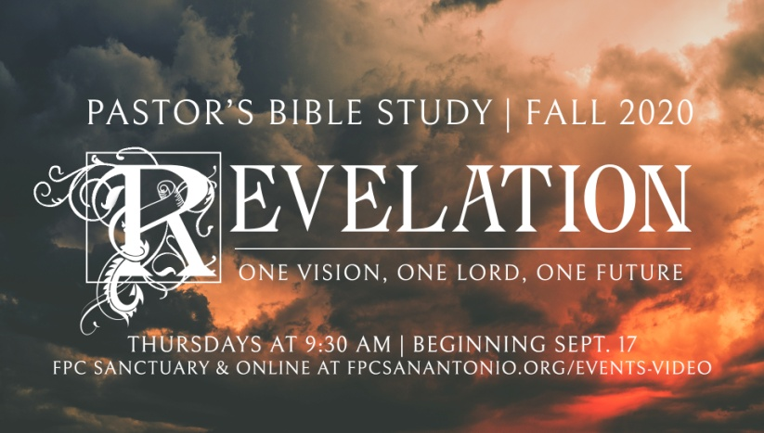

**Questions for Episode 4**

October 7/8, 2020

What do we know about John?

1. Traditionally, who were John's parents?
2. Hilarius and Quieta
3. Joachim and Anna
4. Zebedee and Salome
5. Clotilda and Clovis
6. Before they met Jesus, in what trade were John and his brother James employed?
7. They were farmers
8. They were bakers
9. They sold cloth
10. They were fishermen
11. John and his brother answered Jesus' call to follow him. In the gospel of Mark, which was the first major city in which they stopped?
12. Tel Aviv
13. Safed
14. Lod
15. Capernaum
16. John, along with Peter and James, was present when Jesus performed a miracle. The story is related in Mark 5. Which of the following miracles was it?
17. Jesus healed a man who had been injured in a fall
18. Jesus made a mute boy able to speak
19. Jesus raised the daughter of Jairus from the dead
20. Jesus drove spirits out of a woman
21. John was present at the Transfiguration. True or False
22. When Jesus went to pray in the garden of Gethsemane, he was accompanied by James, John and Peter. The hour was late. What happened to the disciples?
23. They got sick
24. They got hungry and started to eat
25. They were attacked by a badger
26. They fell asleep
27. In Christ's dying agony on the cross, he commended someone to the care of John. Who was it?
28. Andrew
29. Mary
30. Joseph
31. An orphan
32. John spent many years in Jerusalem. Later, he traveled and preached the Gospel throughout Asia Minor. The last years of his life were spent in what city?
33. Damascus
34. Yerevan
35. Riyadh
36. Ephesus
37. What is this book about? (1:1)
38. For whose benefit did God intend the book of Revelation? (1:1)
39. How did God deliver this revelation? (1:1)
40. To whom did God deliver this revelation? (1:1)
41. Why did God give us the book of Revelation? (1:1-3)
42. How much of the revelation he received did John report? (1:2)
43. What sources did John say were the basis of his revelation? (1:2)
44. How did John show urgency in what he wrote? (1:3)
45. Why do you think this New Testament author referred to himself as a servant of Christ?
46. Read Revelation 1:1 and 1:3 taking special note of the time frame references. Did the writings in this book have anything to say about the times in which they were written, or are they focused on another time period?
47. How does it make you feel to realize that God wants us to know what the future holds?