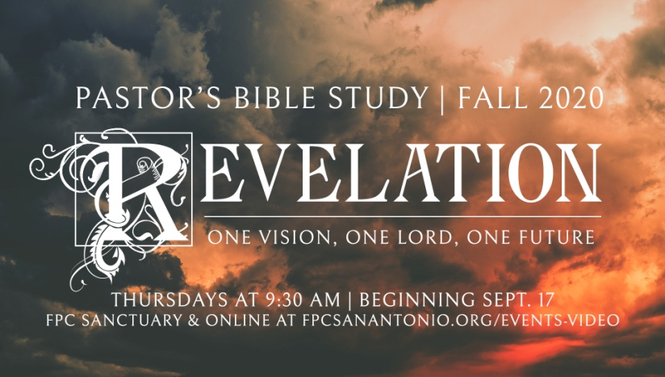

Overview of Revelation

Episode 3

October 1, 2020

Beer Commercial: “It just doesn’t get any better than this!”

God’s response: “It’s going to get a whole lot better than this!”

1. **Introduction**
2. 2 Timothy 3:16-17
3. 2 Timothy 2:15 *Be diligent (or study) to present yourself approved to God, a worker who does not need to be ashamed, rightly dividing the word of truth.*
4. *Historicist, Preterist, Future or Spiritualist:*  How shall we interpret Revelation? Only a consideration acknowledging all of these interpretations will bring us close to the truth revealed to the apostle. We should take Revelation as the living word of God: not bound by literalistic interpretation or symbolic interpretation; not exhausted by history or confined to spirituality; a book whose message is for the redeemed in Christ: past, present and future.
5. **The Setting**

A. The Apostle (Disciple, John Zebedee) John on the Island of Patmos.

B. Takes place on Sunday.

C. John’s Vision

i. The heavenly throne room of God.

ii.The “the Alpha and the Omega, the first and the Last.” The A and Z. God was saying, I am the beginning, the end and Lord over everything in between.

D. John’s Charge: Then the voice said, “What you see, write in a book and send it to the seven churches which are in Asia.”

i. Open letters.

ii.Example: The Christians in the city of Laodicea (3:14-22)

1. **The Five Themes of Revelation**

**A. The Person of Christ**

i. Revelation is one of the few books of the Bible that gives us a picture of Christ as he is now ---- glorious and powerful.

ii.The expectation that Christ will come again and finish the work begun at the crucifixion and resurrection is not unique to Revelation. It is one of the most consistent promises of the New Testament.

**B. The Tribulations or suffering of the earth and its inhabitants**

i. Before Christ comes again, all of the earth (both people and nature itself), will be subjected to catastrophic disasters. Three series of seven disasters, and this period of suffering is called the *tribulation*.

ii.The tribulation will include world war, famine, disease, earthquakes, fire, hail and painful spiritual attacks.

iii. The tribulations are intended as God’s final wake-up call. Revelation tells us over and over again that there are many who will indeed get the message and turn to Christ, and live eternally.

**C. The Rise, rule and fall of the Devil and his servants**

i. During the time of tribulation, those who do not turn to God for salvation will seek help from a counterfeit savior.

ii.Revelation shows that Satan, called the *Dragon* in John’s prophecy, and the *Beast* (or Antichrist) and the *False Prophet* make up a counterfeit trinity, a parody of the real trinity: Father, Son and Holy Spirit.

iii. John tells us that the Satanic Trinity will be brought down, defeated and humiliated at the second coming of Christ, and that those who put their trust in the antichrist will be counted as traitors to God, idolaters who gave themselves to a false God.

**D. The Salvation of the Saints and the punishment of the unredeemed**

i. The Victorious Christ will come to judge the living and the dead throughout history.

ii.God’s judgment will be executed on all people. Those who have served evil, or their own self-interests, those who have not been washed clean by the blood of Christ will perish in their sin, and the full weight of their evil will consume them. But those who have followed Christ, and who trust in him alone for their salvation, shall be ushered into the joy of his eternal kingdom in the New Heaven and New Earth.

**E. The New Creation of God** (Creation not destroyed, but restored) (Genesis-Revelation)

i. The Bible is the story of God’s Generation, Degeneration and Regeneration; Creation, Desecration and Re-creation.

ii.Revelation is not a book of creation destruction but of creation restoration.

1. **“He who has ears let him hear what the Lord is saying to the churches” (2:29)**