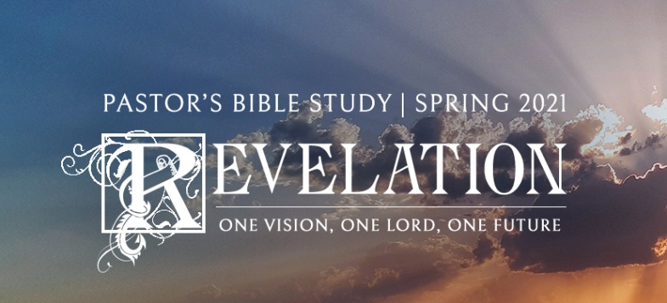

The Marriage Feast and the Rapture

Episode 19

Revelation 19:1-10

March 3/4, 2021

**THE MARRIAGE FEAST OF THE LAMB AND THE SECOND COMING OF CHRIST**

**I. Reformed Theology and the Second Coming (R.C. Sproul)**

1. The New Testament term most often used to point to Christ’s return is the ***Parousia****.* The Parousia refers to the “appearing,” “manifestation,” or “coming” of Jesus in glory at the end of the age. It refers to the church’s expectation of the promised Second Coming or Second Advent of Christ. The belief in the Parousia or presence of Christ in glory is firmly rooted in all strands of the NT, though the expectation can be referred to apart from the Word (Rev. 19:11ff ; 1 Cor. 15:23ff ; Mark 13:26; 14:62) or by use of other terms (e.g., *apokalypsis* in 1 Cor. 1:7;

1 Pet. 1:7). Even in those books where the person of Christ does not loom large (like the letter of James), the Parousia of the Lord (God or Christ?) is referred to (James 5:7).

1. The Bible teaches that Jesus’ coming will be **both personal and visible**. Though His coming will be with power, it will include more than a visitation of His power. It will include His very person. His coming will be neither secret nor invisible. His appearance will be accompanied by clouds of glory in like manner to His departure at the Ascension. There will be a heavenly fanfare of audible shouting, accompanied by the voice of an archangel.
2. At the coming of Christ, the church will experience a **rapture** — being taken up in the air to meet Christ as He comes. The rapture will not be secret but open and manifest. Its purpose will not be to whisk the elect away from the earth for a while until Christ returns for a “second” Second Coming. The purpose of the rapture is to allow the saints to meet Jesus in the air as He returns and be included in His entourage during His triumphal descent from heaven, not as escaping refugees but seasoned veterans. His coming in this manner will be attended by the general resurrection, the final judgment, and the end of the world.

**II. Part One: The Marriage Feast of the Lamb and the Rapture (19:1-10)** v. 7 "Let us be glad and rejoice and give Him glory, for the marriage of the Lamb has come, and His wife has made herself ready."

1. After an interval of betrothal, the groom comes with his friends to the bride’s home, from which he conveys her back to his own home or that of his parents. There the wedding feast is held and the marriage is consummated.
2. Throughout the History of Israel (in the Old Testament) the wedding was announced.
3. The Son of God assumed Flesh and Blood and the Betrothal took place.
4. The Bride Price was paid on Calvary.
5. Now, Christ is coming to get the church and take her home.
6. The Return of Christ to collect his Bride is the Second Advent (Part One) as the Bridegroom. His Second Coming continues when he comes as the Rider on the White horse (in Chapter 19).
7. Verses 8-10. The Angel — the Messenger of the Bridegroom, not the bridegroom.

John the Baptist: ***28****You yourselves bear me witness, that I said, ‘I am not the Christ, but I have been sent before him.’* ***29****The one who has the bride is the bridegroom. The friend of the bridegroom, who stands and hears him, rejoices greatly at the bridegroom’s voice. Therefore this joy of mine is now complete.* ***30****He must increase, but I must decrease.”* John 3:28-30