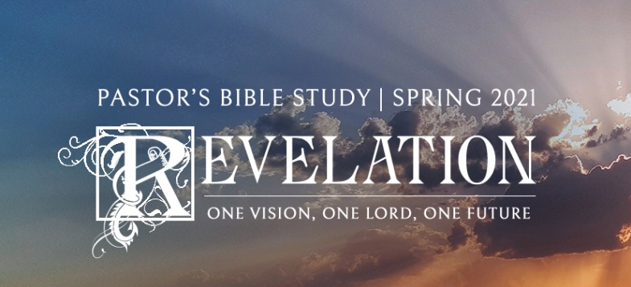

The Bowls and the Harlot of Babylon Episode 17

Revelation 15:1-17:18

February 17/18, 2021

1. **Introduction to the Seven Bowls**
   1. **A Setting image**—Those who remain faithful (15:1-4)
      1. The Worship of the Heavenly Throne Room
      2. Those “who have the victory over the beast, over his image and over his mark *and* over the number of his name, standing on the sea of glass, having harps of God.”
      3. Look where they are: In eternity, singing
   2. **A Contrasting Image:** The Seven Bowls of God’s Wrath: The Seven Angels with the Seven Bowls (15:5-8)
2. **THE SEVEN BOWLS** (16:1-18)

A. Poured out on those who “the men who had the mark of the beast and those who worshiped his image.” (v. 2)

B. Highlights the continued rebellion and blasphemy of the people.

i. (v. 9) *And men were scorched with great heat, and they blasphemed the name of God who has power over these plagues; and they did not repent and give Him glory.*

ii. “(vv. 10-11) *10 They gnawed their tongues because of the pain. 11 They blasphemed the God of heaven because of their pains and their sores, and did not repent of their deeds.*

iii. Compare this to those loyal to the Lamb who say, “*You are righteous, O Lord, The One who is and who was and who is to be, Because You have judged these things”. (v.5)*

iv. (v. 21) *Men blasphemed God because of the plague of the hail, since that plague was exceedingly great.*

C. Armageddon: The Dragon, the Beast and the false prophet begin to gather an army for war against God (vv. 14, 16)

i. v.14 to gather them to the battle of that great day of God Almighty.

ii. v. 16 “And they gathered them together to the place called in Hebrew, ‘Armageddon.’” *Armageddon* is probably HAR-Megiddo: Literally "The hill of Megiddo." Megiddo is a plain that dominates the main pass that goes through the hill country from the plain of Sharon to the Valley of Jezreel. As such, it is strategically located and thus the site of many battles for thousands of years. It is mentioned in Judges 5:19 and 31 where Deborah and Barak sing of the overthrow of the Canaanite kings by the "waters of Megiddo" and add, *"Thus let all thine enemies perish, O Lord."*  It is also mentioned in 2 Kings 23:29 as the place where Pharaoh Neco defeated and killed King Josiah. Pharaoh Thutmose III defeated the Canaanites there in 1486 BC. In 1917 the British defeated and ended the rule of the Turks in Palestine at this valley. Mt Carmel, where Elijah defeated the prophets of Baal, is very close to the plain of Megiddo.

iii. Using the imagery supplied by Scripture, the most we can say is that Har-megiddo is significant, not as a location, but as a symbol of complete eternal defeat and destruction of all (spiritual, religious, political) forces of evil. This is the end of the final and most bold and open opposition of God to man. This is based on the fact that what is described as a hill or a mountain in Revelation (if indeed it is the same place), is, in fact, a strategically located valley. This suggests figurative language, of which the point of comparison is the strategic location.

D. The warning: 15 *"Behold, I am coming as a thief. Blessed is he who watches, and keeps his garments, lest he walk naked and they see his shame."*

**III. The Vision: Babylon and the Harlot** (Chapter 17)

A. 16:19 *Now the great city was divided into three parts, and the cities of the nations fell. And great Babylon was remembered before God, to give her the cup of the wine of the fierceness of His wrath.*

B. Who or what is “Babylon?”

i. Revelation 17:1 *Then one of the seven angels who had the seven bowls came and talked with me, saying to me, "Come, I will show you the judgment of the great harlot who sits on many waters, 2 "with whom the kings of the earth committed fornication, and the inhabitants of the earth were made drunk with the wine of her fornication."*

C. The Woman (the Harlot): *“(3,4) a woman… arrayed in purple and scarlet, and adorned with gold and precious stones and pearls, having in her hand a golden cup full of abominations and the filthiness of her fornication.”*

i. v. 15 The Harlot: When the Church becomes the mistress of the state. Babylon is the rival power of God (an earthly kingdom claiming divine).

ii. An empire: *15 Then he said to me, "The waters which you saw, where the harlot sits, are peoples, multitudes, nations, and tongues.”*

iii. Harlot- Owned, used, degraded, but not loved by the Dragon or the beast (16 "And the ten horns which you saw on the beast, these will hate the harlot, make her desolate and naked, eat her flesh and burn her with fire.”).

iv. 144,000 (Chapter14) not seduced by the Harlot of Babylon.

1. “These are the ones who were not defiled with women, for they are virgins.” (14:4)
2. Did not drink from the cup of Babylon’s fornication (14:8)
3. See Hosea 1:2 (*When* the LORD began to speak by Hosea, the LORD said to Hosea: "Go, take yourself a wife of harlotry And children of harlotry, For the land has committed great harlotry *By departing* from the LORD.”)

v. She is a murderer as well as a harlot *(v.6) … drunk with the blood of the saints and with the blood of the martyrs of Jesus.*

vi. The Scarlet Beast: sitting on a scarlet beast *which was* full of names of blasphemy, having seven heads and ten horns.

1. Carrying the Harlot
2. The Beast is the color of blood

**IV. The Mystery (or Vision explained)**

A. MYSTERY, BABYLON THE GREAT, THE MOTHER OF HARLOTS AND OF THE ABOMINATIONS OF THE EARTH.

i. This is her name.

ii. “Mystery” means some specialized knowledge that could not be known by reason. It must be revealed. One must be initiated into it. We could not figure it out on our own—we must be told.

B. The Angel reveals the mystery.

C. v. 8 *The beast that you saw was, and is not, and is about to rise from the bottomless pit and go to destruction. And the dwellers on earth whose names have not been written in the book of life from the foundation of the world will marvel to see the beast, because it was and is not and is to come.*

D. The Seven Heads:

i. 9 *"…The seven heads are seven mountains on which the woman sits.* (Rome? Rome sits on seven hills (identified as the point of comparison in verse 9).

ii. 10 "*There are also seven kings. Five have fallen, one is, and the other has not yet come. And when he comes, he must continue a short time.* (Emperors, Old Kingdoms, Old Powers to be replaced by the new powers). The harlot rode into history on the back of the Roman Empire (Scarlet beast) which had seven different forms of government (seven kings) up to and including the administration of Diocletian. According to the Roman constitutional history, Diocletian is considered founder of the seventh Roman Empire.

iii. That the woman, the apostate church, rides on the beast with seven heads and ten horns, symbols of political power, indicates that the apostate church will operate in alliance with secular authority.

iv. The Harlot - The Church of the Beast – Babylon - Political Power – Rome.

v. Was…, is not (will return).

1. 11 *"And the beast that was, and is not, is himself also the eighth, and is of the seven, and is going to perdition.*

2. (A parody of the Resurrection?—a counterfeit “Who was and is and is to come?”

3. Will be of the old regime, but new power, new manifestation, new form?

E. The Ten Horns: *12 "The ten horns which you saw are ten kings who have received no kingdom as yet, but they receive authority for one hour as kings with the beast.*

i. A purge or Stalinist type coup that clears out the old leadership and replaces it with new?

ii. 13 "These are of one mind, and they will give their power and authority to the beast. (New Sycophants). Hitler’s SS versus the SA (Brownshirts - Old Guard).

**V. God is in Control**

A. 14 *They will make war with the Lamb, and the Lamb will overcome them, for He is Lord of lords and King of kings; and those who are with Him are called, chosen, and faithful.*

B. (17 *"For God has put it into their hearts to fulfill His purpose, to be of one mind, and to give their kingdom to the beast, until the words of God are fulfilled.”*) God is using all of this activity to His own purposes.

C. (18 *"And the woman whom you saw is that great city which reigns over the kings of the earth."*). The harlot shall remain while human history remains, but shall unwittingly serve God's ultimate purposes, just as Satan, incited against Jesus Christ, stirred the mobs to kill Him ultimately fulfilled all prophecy and resulted the accomplishment in God's purpose of saving us. When did the Roman empire really fall? Roman Culture never died. The papacy?