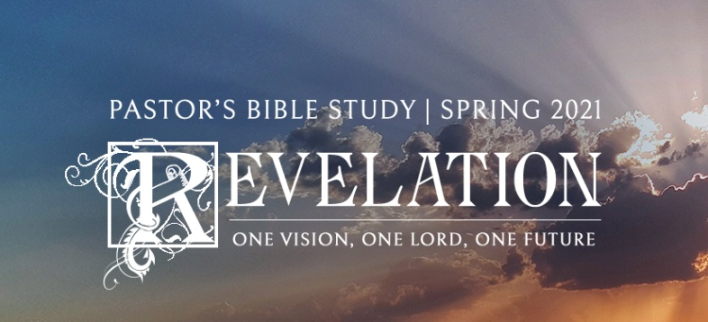

**Questions for Episode 15**

February 3/4, 2021

1. In what ways are you tempted to place your affections on the world of business, politics, social life, etc.?
2. Who did John see standing before him? (14:1)
3. Where in this vision of John's was the central character standing? (14:1)
4. Who was standing with the Lamb? (14:1)
5. What was written on the foreheads of the 144,000? (14:1)
6. What was the sound that John heard from heaven like? (14:2)
7. What did the 144,000 do as John looked on? (14:3)
8. Who besides John heard the 144,000 singers? (14:3)
9. Who was given the privilege of learning the song of the 144,000? (14:3)
10. How is the purity of the 144,000 described? (14:4)
11. How is the commitment and faithfulness of the 144,000 pictured? (14:4)
12. What is said here about the unique spiritual condition of the 144,000? (14:4-5)
13. How is the integrity of the 144,000 described? (14:5)
14. What is significant about the sound from heaven described in this passage?
15. Why do you think only the 144,000 are able to learn the new song of praise?
16. In your own words, how would you describe the redeemed 144,000?
17. What does it mean to "follow the Lamb wherever he goes"?
18. What does it mean to be blameless?
19. What is one step you can take today to keep yourself pure and devoted to God?
20. What can you do to make yourself more open to follow the Lord wherever He leads you?