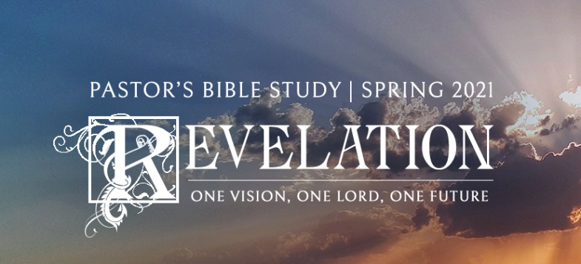

The Rise of the Beast

Revelation 13:1-18

January 27/28, 2021

*“…But woe to you, O earth and sea, for the devil has come down to you in great wrath, because he knows that his time is short!” [1]* Revelation 12:12

**I. Introduction:** The “Satanic Trinity” or “Counterfeit Trinity”: Satan, His “Incarnation” (AntiChrist), The False Prophet (Parody of the Holy Spirit)

**II. The Beast from the Sea: The AntiChrist** **(13:1-10)**

a. Description is similar to that of the dragon (seven heads, ten horns, crowns) but more detailed.

b. Blasphemous Names—The Roman emperors and other potentates have often given themselves “divine,” semi-divine, or transcendent titles. Antiochus epiphanies, Caesar Kurios (lord), Louis the XIV of France - “I am the State,” Hitler, the Fuhrer (leader).

c. The Beast is the “incarnation” of the dragon on earth. The worship of the beast (names that put the beast on the level with God and demand worship).

d. “Rising up out of the sea” (out of the Chaos—*Tohoo vavohoo*) or, out of the Mediterranean (out of the West – Roman empire?).

e. Physical / Symbolic Description (what John saw).

i. Combines features (attributes) of the beasts (kingdoms) prophesied in Daniel 7:1-8; 17-27.

ii. Unknown Hybrid Monster…Rome.

iii. Leopard…Greeks / Macedonian.

iv. Bear …Medo-Persian Empire.

v. Lion…Babylonia.

f. John, looking back, reverses the historical order of Daniel’s vision (which looks forward: Lion, Bear, Leopard, Unknown Hybrid Monster).

g. The Dragon gives him power (Like a Mafia boss gives his lieutenants power over a neighborhood).

h. Comes in Power — Christ (The lion of Judah—the Lamb) came in weakness and humility.

i. People follow and worship the beast. People are enamored of power—even evil power (Hitler, Stalin, Mao were all loved).

i. One of the heads mortally wounded (dead) but was healed (does not actually die). A blasphemous parody of the Resurrection.

*ii. v. 4 Men worshiped the dragon because he had given authority to the beast, and they also worshiped the beast and asked, "Who is like the beast? Who can make war against him?"*

j. Makes war against the true faith and gospel—replaces it with counterfeit worship.

k. It looks as though he wins when he makes war with the saints.

l. The comfort to the saints—the warning to others: “v. 10 He who leads into captivity shall go into captivity; he who kills with the sword must be killed with the sword. Here is the patience (perseverance) and the faith of the saints.”(New King James Version; better translation than the NIV.

**III. The Beast form the Earth**: **The False Prophet (13:11-18)**

a. 2 Horns like a lamb but spoke like a dragon: *Two*. Whereas *one* represents unity—*two* represents division, rivalry. Represents man’s enmity to God (Bullinger).

b. Exercises the authority of the First Beast.

c. Compels worship of the First Beast.

d. Signs (Miracles) Fire from Heaven—a counterfeit Elijah—a counterfeit Pentecost.

e. Preaches the power of the beast, who was wounded by the sword but lives.

f. Creates the Image of the Beast (Mass Media?).

i. It Speaks.

ii. It Kills.

**IV. The Mark of the Beast (666)**

a. The False Prophet administers the mark of the Beast on the hand and forehead (parody of Deuteronomy 6:6-8. *“And these words which I command you today shall be in your heart…You shall bind them as a sign on your hand, and they shall be as frontlets between your eyes.”*) Like the phylactery: on the hand and forehead.

b. Six .

i. One less than divine perfection.

ii. 3 x 2, division raised to the third power.

iii. 666—emphasis rather than numerical value (more like 63) Like (Holy, Holy, Holy= Holy3).

iv. In Greek, 666 is represented jjj or sss. (The Greek is *stigma, stigma, stigma*, a variant form of the lower case s [sigma]. Ordinarily, the sixth letter of the Greek alphabet is the letter z (zeta), but the *stigma* was used because it had a particularly sinister connotation consistent with ancient feelings about the number 6. The Greek word *stigma* means a *mark,* but especially a mark like a cattle brand, or a *wound-print*. Used to mark slaves, prisoners, and used by some pagan cults as a mark of devotion. An ancient pagan mystery cult symbol for devil or demonic worship. Can also refer to ritual scarring or tattoos. Means “owned by, or subservient to, or under the authority of the beast.” “I don’t see your name on it.”

v. 666, or 616 (Nero) actual name, or symbolic name.

vi. It refers to a human. A “Human Number.”

1. Man was created on the sixth day.

2. Man has six days to labor—secular completeness; God created the world in seven days—divine completeness.

3. Just less than God—“A day late and a dollar short.”

4. This is a human being, all descriptions therefore are symbolic.

1. [*The Holy Bible: English Standard Version*](https://ref.ly/logosres/esv?ref=BibleESV.Re12.12&off=62&ctx=+who+dwell+in+them!+~But+d%EF%BB%BFwoe+to+you%2c+O+). (2016). (Re 12:12). Wheaton, IL: Crossway Bibles.