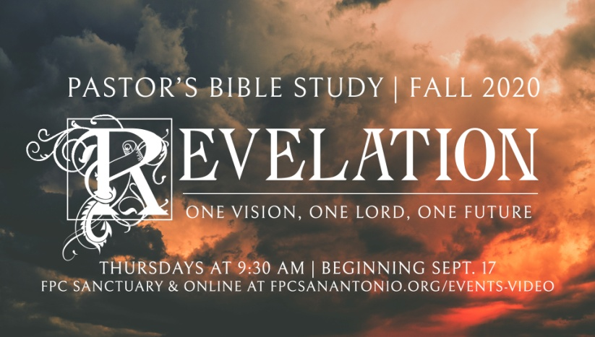

**Questions for Episode 10**

November 18/19, 2020

1. Who did John see after the breaking of the first six seals? (7:1)
2. What power or authority did the four angels possess? (7:2)
3. How many individuals were sealed from each of the 12 tribes of Israel? (7:4-8)
4. How has God marked or sealed His people?
5. Why is it important for us to know that God's servants will be sealed before God afflicts the land and the sea with the final judgments?
6. Where did John see a great throng of people? (7:9)
7. What was the crowd before the throne saying? (7:10)
8. How did the elder explain the identity of those wearing the white robes? (7:14)
9. What is the main job of the believers who come out of the great tribulation? (7:15)
10. What blessings await those who are martyred in the great tribulation? (7:16-17)
11. What is the difference between singing a hymn and singing an ordinary song?
12. How do we know that God does not favor people for their skin color or ethnic background?
13. What happened in heaven upon the opening of the seventh seal? (8:1)
14. In what ways can silence be good or helpful? In what ways can silence make us uncomfortable?
15. For how long was there silence in heaven during John's vision? (8:1)
16. What did John see after the opening of the seventh seal? (8:2)
17. What was given to the angels seen by John? (8:2)
18. When the seventh seal is opened there is first silence, then prayer; how do you interpret the heavenly response to the saints' prayers?
19. What does this passage teach us about prayer?
20. What needs are you praying about these days?
21. The angels in heaven have God-given tasks; what are your God-given tasks or areas of responsibility?
22. When could you make time this week for silent meditation on God's Word and on what God has done for you?